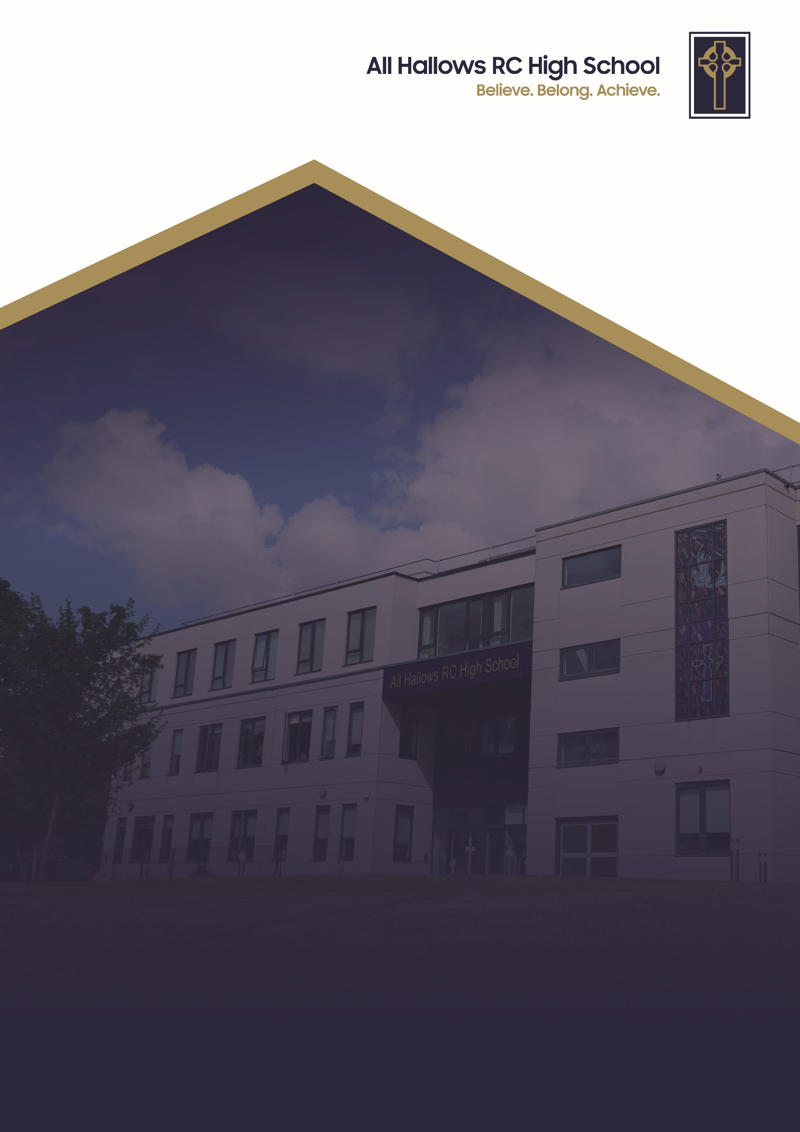
SEN POLICY

Committee Responsible for Review: Welfare
Review Date: October 2026
Date of Next Review: October 2027



At All Hallows RC High School, we are a Christ-centred community committed to living out the Gospel values in every aspect of our school life. Our school mission is to inspire, support and challenge every member of our school. We believe that every person is created in the image of God and that they grow in faith guided by the teachings of Christ. We strive to foster an environment where love, peace, courage, justice and kindness guide our actions so we develop into compassionate, resilient individuals who contribute positively to the world around them.

We are a community built on love, demonstrating unconditional respect and kindness for all. By fostering strong relationships, we ensure that every individual feels that they belong, are valued, supported and accepted as part of our family. We celebrate our differences and each person’s uniqueness. We encourage forgiveness and understanding to create an environment where every pupil can flourish in their own way.

Through these values, All Hallows RC High School nurtures the whole person spiritually, academically and socially so they can achieve. We are a school where the Gospel values are not just ideals but the foundation of everything we do. With Christ at the centre, we enrich the lives of our pupils and guide them on the path of faith, purpose and integrity.

1 . Aims
Our SEN policy and information report aims to:
- Set out how All Hallows RC High School will support and make provision for pupils with special educational needs (SEN).
- Explain the roles and responsibilities of everyone involved in providing for pupils with SEN.
As a Catholic school, our mission is to provide a high-quality education rooted in Gospel values, where the dignity and unique value of every individual is recognised and respected.
We are committed to an inclusive philosophy, where every teacher is a teacher of SEN and responsible for ensuring that pupils with additional needs are supported to participate fully in school life.
We aim for all pupils to:
- Achieve their best.
- Become confident individuals with fulfilling lives.
- Make a successful transition into adulthood, employment, further or higher education, or training.
- Access a broad, balanced, and ambitious curriculum.
- Be set high expectations that enable them to thrive.
- Learn in lessons that anticipate and remove barriers to progress.

2. Legislation and guidance
This policy is based on the statutory:
- Part 3 of the Children and Families Act 2014
- Special Educational Needs and Disability Regulations 2014
- SEND Code of Practice (0–25 years), 2015
- Equality Act 2010 (duties for schools to make reasonable adjustments)
- JCQ Access Arrangements and Reasonable Adjustments 2025/26 (for pupils with SEND requiring exam support)
It also complies with our funding agreement and articles of association.

3. Definitions
A pupil has SEN if they have a learning difficulty or disability which requires special educational provision to be made for them.
A pupil is considered to have a learning difficulty or disability if they:
- Have a significantly greater difficulty in learning than the majority of their peers of the same age, or
- Have a disability that prevents or hinders them from making use of the educational facilities generally provided in mainstream schools.
Special educational provision is educational or training provision that is additional to, or different from, that made generally for other children of the same age in a mainstream school.

4. Roles and responsibilities

4.1 The SENCO
Our SENCO is Nicola Jackson, Director of Inclusion and member of the Senior Leadership Team.
Deputy SENCO: Nicky White.
Both hold the National Award for SENCO.
Responsibilities include:
- Leading the strategic development of SEN policy and provision.
- Day-to-day management of SEN provision, including pupils with EHC plans.
- Providing guidance to colleagues and working with families and agencies.
- Overseeing the graduated approach (assess, plan, do, review).
- Managing SEN resources and budget effectively.
- Ensuring compliance with the Equality Act 2010 regarding reasonable adjustments and access arrangements.
- Maintaining accurate records of pupils with SEN.

4.2 SEN Governor
Mrs D Hanley is the SEN Governor.
Responsibilities include:
- Raising awareness of SEN at governing body level.
- Monitoring SEN provision and effectiveness.
- Supporting strategic development alongside the SENCO and Headteacher.

4.3 Headteacher
Mrs E Walker is the Headteacher.
Responsibilities include:
- Overall responsibility for provision and progress of pupils with SEN.
- Ensuring SEN is integral to school improvement priorities.

4.4 Class Teachers
All teachers are responsible for:
- The progress and development of every pupil in their class.
- Working with TAs and specialist staff to plan support and interventions.
- Reviewing pupil progress with the SENCO and adapting provision as needed.
- Delivering high-quality teaching, differentiated to meet need.
- Implementing this SEN policy in daily practice.

5. SEN information report
5.1 The kinds of SEN that are provided for
Our school currently provides additional and/or different provision within the Broad areas of needs outlined in the SEN code of practice. These may include:
- Communication and interaction, for example, speech and language difficulties,
- Cognition and learning, for example, Dyslexia, Dyspraxia, Moderate Learning Difficulties,
- Social, emotional and mental health difficulties, for example, Attention Deficit Hyperactivity Disorder (ADHD),
- Sensory and/or physical needs, for example, visual impairments, hearing impairments, processing difficulties, physical disabilities.

5.2 Identifying pupils with SEN and assessing their needs
We will assess each pupil’s current skills and levels of attainment on entry, which will build on previous settings and Key Stages, where appropriate. Class teachers will make regular assessments of progress for all pupils and identify those whose progress:
- Is significantly slower than that of their peers starting from the same baseline
- Fails to match or better the child’s previous rate of progress
- Fails to close the attainment gap between the child and their peers
- Widens the attainment gap
This may include progress in areas other than attainment, for example, social needs.
Slow progress and low attainment will not automatically mean a pupil is recorded as having SEN.
When deciding whether special educational provision is required, we will start with the desired outcomes, including the expected progress and attainment, and the views and the wishes of the pupil and their parents. We will use this to determine the support that is needed and whether we can provide it by adapting our core offer, or whether something different or additional is needed.
The detailed SEN information report can be found in the SEND section on the website.

5.3 Consulting and involving pupils and parents
We will have an early discussion with the pupil and their parents when identifying whether they need special educational provision. These conversations will make sure that:
- Everyone develops a good understanding of the pupil’s areas of strength and difficulty.
- We take into account the parents’ concerns.
- Everyone understands the agreed outcomes sought for the child.
- Everyone is clear on what the next steps are.
Notes of these early discussions will be added to the pupil’s record and given to their parents.
We will formally notify parents when it is decided that a pupil will receive SEN support.

5.4 Assessing and reviewing pupils' progress towards outcomes

At All Hallows, we follow the statutory graduated approach set out in the SEND Code of Practice:
- Assess – Class teachers, supported by the SENCO, assess the pupil’s needs, drawing on teacher assessments, data, parent views, pupil voice, and advice from external professionals where appropriate.
- Plan – Targets and support strategies are agreed with parents, the pupil, and staff. This may include classroom strategies, additional resources, or interventions.
- Do – The support and interventions are put in place. Teachers remain responsible for every child’s progress, working closely with TAs or specialist staff.
- Review – Progress is reviewed regularly (at least once each term). If a pupil is not making expected progress, the cycle is revisited and provision adjusted.
Where a pupil continues to make limited progress despite well-evidenced support, the school may request an Education, Health and Care (EHC) needs assessment from the local authority.

5.5 Supporting pupils moving between phases and preparing for adulthood
We recognise that transitions are critical times for pupils with SEN. We provide enhanced support at:
- Primary to Secondary Transfer (Year 6 → Year 7):
  - Early contact with feeder schools.
  - Attendance at Year 6 annual reviews for pupils with EHCPs.
  - Extra visits for vulnerable pupils.
  - Transition packs and meetings with parents.
- Key Stage Transitions (KS3 → KS4):
  - Careers advice tailored to pupils with SEN.
  - Guidance for option choices with SENCO support.
- Post-16 Transition (Year 11 → College/Training):
  - SENCO works with colleges and training providers.
  - Additional visits and taster sessions where needed.
  - Sharing of support strategies and reports with new settings.
  - Attendance of Post-16 providers at Year 11 reviews for pupils with EHCPs.
This ensures every pupil is prepared for their next stage of education, employment, or training.

5.6 Our approach to teaching pupils with SEN
Teachers are responsible and accountable for the progress and development of all the pupils in their class.
High quality teaching is our first step in responding to pupils who have SEN. This will be differentiated for individual pupils.
We offer a range of interventions which may include the following:
- Literacy and numeracy
- Lexia
- Touch typing
- Speech and language
- Social Skills
- SEMH
Interventions are implemented where it is deemed appropriate for the individual child and based on feedback from screening tests/ advice from external agencies.
We also have dedicated spaces in school that provide support for a range of needs:
The Bosco Centre
The Bosco Centre provides short-term, tailored support for Key Stage 3 and Key Stage 4 pupils who need help managing their SEMH needs and improving their behavior for learning.
We balance academic learning with emotional support: students keep up with their timetabled lessons while receiving targeted Cognitive Behavioral Therapy (CBT) from a trained therapeutic counselor.
When a pupil is ready to return to mainstream classes, we collaborate with subject teachers on the best strategies to support them. Students transition back gradually with TA support, guided by regular target setting and progress monitoring to help them thrive.

The Lourdes Centre
Like the Bosco Centre, the Lourdes Centre serves as a dedicated base for pupils with SEMH needs. It specifically supports students experiencing anxiety, low mood, and related SEMH challenges that benefit from a therapeutic approach. Depending on the child's individual needs, 1:1 support and group sessions are available. The Mental Health Lead collaborates directly with relevant professional services whenever external involvement is required.

Nurture Form
This form group is specifically designed for Year 7 pupils identified during primary school transition discussions as needing extra support. Led by the Deputy SENCo, the group provides focused guidance during the settling-in period. Towards the end of the summer term, pupils will transition into their permanent form group, where they will remain for the rest of their time at All Hallows.
Aquinas Centre
This is the Enhanced Resourced Provision for students with Speech and Language Difficulties and Moderate Learning Difficulties. Pupils are placed in this provision through the SEN Local authority team in consultation with the school. Students accessing this provision must have an EHC plan specifying their primary need as one of those mentioned above and also specify that they have a place within the Enhanced Resourced Provision. Pupils in this provision may spend a lot of their time in this area for their learning. Pupils are integrated into mainstream lessons following a review meeting with parents to ensure that appropriate support is in place at home and in school. Teaching in this area is through mainstream specialist teachers and qualified SEN teachers.

5.7 Adaptations to the curriculum and learning environment
At All Hallows RC High School, we are committed to making reasonable adjustments to remove barriers to learning so that all pupils can access a broad and balanced curriculum. Adaptations are tailored to individual needs and may include:
- Curriculum differentiation – adapting planning, grouping, and teaching approaches to match learning styles and abilities; offering 1:1 support or small-group interventions where required.
- Resource and staffing adjustments – providing additional adult support, adapted learning materials, or alternative recording methods.
- Specialist aids and assistive technology – e.g. laptops, coloured overlays, reading pens, visual timetables, enlarged print, or other resources recommended by external specialists.
- Adapted teaching strategies – e.g. extended processing and response times, scaffolding tasks, pre-teaching of key vocabulary, breaking down instructions, use of visual supports, and repetition for reinforcement.
- Learning environment adaptations – adjustments to seating, acoustics, lighting, and access arrangements, ensuring an inclusive and supportive classroom setting.
These adaptations are regularly reviewed as part of the graduated response to ensure they remain effective, reflect the pupil’s normal way of working, and maintain the integrity of the curriculum and assessment.

5.8 Additional support for learning
We have a large number of teaching assistants who are trained to deliver a wide range of interventions such as ELKAN, social skills and reading. The SENCO, deputy SENCO, SEN teacher, LSC manager and other teaching staff also hold the qualification.
Teaching assistants are deployed to departments and the SENCO identifies where support is best utilized. Teachers will then ensure that within the lesson the teaching assistant supports students in the most effective and appropriate way. Students are not assigned a 1:1 teaching assistant however they may work 1:1 on particular tasks or activities depending on teacher requirements or the SENCO discretion.
We work with the following agencies to provide support for pupils with SEN:
- Educational Psychologist who is able to work with staff, pupils and parents
- SEN Consultant
- Secondary Inclusion Service
- Learning Support Service
- EMTAS for both Traveller and EAL pupils
- Connexions Officer
- SEN Caseworker
- Autistic Spectrum disorders Team (ACE)
- School Health Professional
- Social Services (Families and Care Team)
- Community Physiotherapist
- Occupational Therapy
- Speech and Language Therapy
- Visual Impairment Service
- Hearing Impairment Service
- Oakwood High School
- Broadwalk + Clifton – outreach work
- Newpark – advice and outreach work
- School Nurse
This is not an exhaustive list.
We will consult any service that may be relevant.

5.9 Expertise and training of staff
Our SENCO has 16 years of experience in this role and has completed the National Award for SENCOs. She also holds the Level 7 OCR Diploma in Assessing Specific Learning Difficulties and has recently completed a Master’s Degree in Educational Leadership with Chartered Manager status. The Deputy SENCO also holds the NASENCO qualification.
We have a dedicated team of 10 full-time teaching assistants and a further 6 teaching assistants who also hold additional responsibilities within the school. Staff are provided with a wide range of continuing professional development (CPD) opportunities to strengthen their knowledge and understanding of SEN, including training in Emotion Coaching, building resilience, and understanding Attachment and Trauma. All teaching and support staff also undergo annual safeguarding training.
We employ a full-time SEN teacher within the Aquinas Centre, who is suitably trained to work with students presenting with speech, language and communication difficulties, as well as moderate learning difficulties.
To support pupils’ wellbeing, we use both specialist internal staff and external agencies. For example, we provide in-school counselling and access to mental health support through Caritas counselling.
In addition, the school is part of the Salford Thrive in Education model, which enables us to work closely with external mental health services, including 42nd Street and the CAMHS i-Reach service, ensuring pupils receive timely and targeted support.

5.10 Securing equipment and facilities
We have a suitable budget that ensures we are able to provide resources and equipment for students with SEN to allow them full access to the curriculum. Where a child needs specialist resources or equipment we may request additional funding from the local authority to support this in the form of the Education Health and Care plan, demonstrating the graduated approach and the efficient use of school resources.

5.11 Evaluating the effectiveness of SEN provision
We evaluate the effectiveness of provision for pupils with SEN by:
- Reviewing pupils’ individual progress towards their goals each term.
- Reviewing the impact of interventions after a set number of weeks/sessions depending on the intervention e.g. 6 week programme.
- Using pupil questionnaires.
- Monitoring by the SENCO.
- Using provision maps to measure progress.
- Holding annual reviews for pupils with statements of SEN or EHC plans.
- Pupil and parent voice.
- External agency reviews.

We are proud to be recognised with the SEN Inclusion award (SENDIA) which demonstrates our dedication towards ensuring quality provision for pupils with SEN.

5.12 Enabling pupils with SEN to engage in activities available to those in the school who do not have SEN
All of our extra-curricular activities and school visits are available to all our pupils, including our before-and after-school clubs.
All pupils are encouraged to go on our residential trips e.g. Year 7 trip to PGL.
All pupils are encouraged to take part in events that are carried out in school
No pupil is ever excluded from taking part in these activities because of their SEN or disability. Additional support for pupils with SEN or disability attending these trips can be provided in consultation with parents and teachers, where appropriate.
Where appropriate, adaptations are made to ensure that a child with SEN or a disability can access the classroom environment and have the resources and support to access the learning. This is done in consultation with the child, parent, teacher and other professionals (where appropriate)
The school has an accessibility policy can be found on the school website under ‘Policies’.
Pupils with SEN or disability apply for a place at the school through the Local Authority admissions process. Those children with an Education, Health and Care plan will need to apply through the Local Authority SEN team.

5.13 Support for improving emotional and social development
We provide support for pupils to improve their emotional and social development in the following ways:
- Pupils with SEN are encouraged to be part of the school council.
- Pupils with SEN are also encouraged to be part of all clubs to promote teamwork/building friendships etc.
- Pupils with SEN are encouraged to attend trips and visits.
We have a zero tolerance approach to bullying. Please refer to the school Anti- Bullying Policy available on the school website for further information.
https://www.allhallowssalford.com/policies/antibullyingpolicy
5.14 Working with other agencies
We adapt a graduated response model in which we increase the level of support according to need and progress, using the, assess, plan, do, assess review cycle. Movement is determined by the following:
- Feedback from pupils’ teachers
- Insufficient or significant progress on that stage
- Need to involve outside agencies
- Results of screening test that may highlight a concern
- A request from parents/carers for EHCP assessment
- On advice from outside agency

When we identify pupils making less than expected progress given their age and individual circumstances we place them on the SEN list. We then follow Salford LA recommendation to Identify support Intervention Bands (SIB) A, B and C as part of our graduated response model.
Progress is characterised by that which:
- Is significantly slower than that of their peers starting from the same baseline.
- Fails to match or better the child’s previous rate of progress
- Fails to close the attainment gap between the child and their peers.
- Widens the attainment gap

5.15 Complaints about SEN provision
Complaints about SEN provision will normally be directed in the first instance to the class or subject teacher, who may then refer them to the SENCO. In the unlikely event of a matter not being resolved by the SENCO or PPL, parents should then refer the matter to the Headteacher. A formal complaint can be made in writing to the chair of governors in the event that a matter remains unresolved, having already been referred to the Headteacher.
The parents of pupils with disabilities have the right to make disability discrimination claims to the first-tier SEN tribunal if they believe that our school has discriminated against their children. They can make a claim about alleged discrimination regarding:
- Exclusions
- Provision of education and associated services
- Making reasonable adjustments, including the provision of auxiliary aids and services

5.16 Contact details of support services for parents of pupils with SEN
Information regarding the support services for parents of pupils with SEN can be found in the school SEN information report available on the school website under ‘policies’.

5.17 Contact details for raising concerns
You may wish to raise a concern with your child’s form tutor or class teacher in the first instance. You can also raise a concern to any of the key staff below:
Ms N Jackson Assistant Headteacher/SENCO
Mrs N White Deputy SENCO
Miss R Lee/ Mr C Jackson Yr 7 HOY
Mrs H McHale Yr 8 HOY
Mr J D’Costa Yr 9 HOY
Miss K Milan-Snee Yr 10 HOY
Mr A Hren Yr 11 HOY
Mrs E Hambelton Social Inclusion officer
Mrs M Done Senior Assistant Headteacher (Designated Safeguarding Lead)
Mrs E Walker Headteacher
TBC SEN governor

5.18 The local authority local offer
The Salford Local Offer provides clear, accessible information about the education, health, social care, and training services available for children and young people with special educational needs and disabilities (SEND), and their families. All Hallows RC High School contributes to the Local Offer by publishing detailed information about our Enhanced Resourced Provision, SEN Policy, and SEN Information Report on our school website, ensuring parents, carers, and professionals can see how we support pupils with SEND and how we work in partnership with Salford Local Authority and external agencies to secure the best outcomes for our students.
Salford Local Offer: Salford SEND Local Offer

6. Monitoring arrangements
This policy and information report will be reviewed by the SENCO every year. It will also be updated if any changes to the information are made during the year.
It will be approved by the governing body.

7. Links with other policies and documents
This policy links to our policies on:
- Accessibility plan
- Behaviour
- Equality information and objectives
- Supporting pupils with medical conditions
- Child protection and safeguarding

