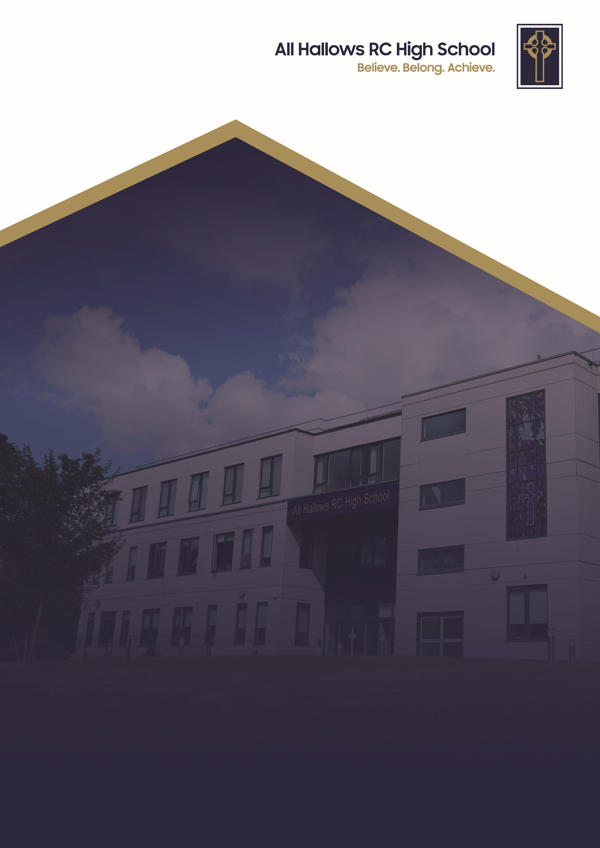
BEHAVIOUR POLICY

Committee Responsible for Review: Welfare Committee
Review Date: September 2025
Date of Next Review: September 2027

BEHAVIOUR POLICY

At All Hallows RC High School, we are a Christ-centred community committed to living out the Gospel values in every aspect of our school life. Our school mission is to inspire, support and challenge every member of our school. We believe that every person is created in the image of God and that they grow in faith guided by the teachings of Christ. We strive to foster an environment where love, peace, courage, justice and kindness guide our actions so we develop into compassionate, resilient individuals who contribute positively to the world around them.
We are a community built on love, demonstrating unconditional respect and kindness for all. By fostering strong relationships, we ensure that every individual feels that they belong, are valued, supported and accepted as part of our family. We celebrate our differences and each person’s uniqueness. We encourage forgiveness and understanding to create an environment where every pupil can flourish in their own way.
Through these values, All Hallows RC High School nurtures the whole person spiritually, academically and socially so they can achieve. We are a school where the Gospel values are not just ideals but the foundation of everything we do. With Christ at the centre, we enrich the lives of our pupils and guide them on the path of faith, purpose and integrity.

All Hallows RC High School aims to provide a safe and secure school environment which fosters self-discipline and respect for school members and the wider community, the ‘All Hallows Way’. Pupils’ efforts to achieve this are recognised and rewarded. Pupils who display anti-social or disruptive behaviour patterns are helped and supported by a variety of agencies and strategies.

This policy has been reviewed in conjunction with the publication by the Dfe “Behaviour in Schools – advice for Headteachers and school staff” February 2024

The behaviour policy relies on a close partnership between staff, pupils and governors in order to achieve its aims. The school promotes the ‘language of choice’, along with rights and responsibilities of all. Every teacher has the right to teach and every pupil has the right to learn, with everyone’s responsibility to achieve this.

All pupils are expected to follow the registration routines and classroom procedures and all teachers are expected to implement them consistently.

REGISTRATION ROUTINE

- Take off your coat

- Stand quietly for prayers

- Give in absence notes

- Take out of your bag:

  - Pen
  - Pencil
  - Ruler
  - Planner – for inspection
CLASSROOM RESPONSIBILITIES

BE

- PROMPT

- PREPARED

- POSITIVE

- PRODUCTIVE

- POLITE

ASSERTIVE DISCIPLINE

The school uses a system of Assertive Discipline to promote good behaviour involving a range of rewards and sanctions which have been developed by staff and pupils to deliver consistent standards of expectations and behaviour in the classroom.

A copy of expectations and the assertive discipline (C3 system) and the ‘All Hallows Way’ will be displayed in all classrooms.

REWARDS SYSTEM

Recognition Points

Recognition points will be given by teachers to reward good work, effort, behaviour and attendance. Pupils can also gain extra recognition points for attending extra-curricular clubs and activities.

Teachers will use Edulink to issue Recognition points; this will be done during the lesson and pupils will be made aware of the recognition by the teacher . Form tutors will share the recognition points tally with pupils during extended form time when working towards ‘The All Hallows Way’ charter. The total amount of recognition points achieved by a pupil in each term contributes to whether a pupil can achieve their bronze, silver and gold charter award.

Pupils are also allocated recognition points for their attitudes outside of the classroom. Teachers and support staff will recognise pupils 'for doing the right thing' by signing a pupil's respect card on the recognition points section of the card. Form tutors will collate the number of points from the respect card and will add these onto the pupil’s profile via Edulink. Parents have access to the Edulink app so that they can view the number of recognition points their child has received and from which teachers and subjects.

The All Hallows Charter recognises pupils that achieve bronze, silver or gold charter via plethora of reward activities at the end of the Autumn, Spring and Summer term. Excellent behaviour and recognition points are two of the contributing factors that determine if a pupil achieves a charter award.

SANCTIONS IN THE CLASSROOM

- The school uses the ‘C3 assertive discipline system’ to encourage pupils to follow classroom rules. This system uses an escalation of intervention within the classroom. It gives pupil a chance, a choice and a consequence if necessary.

C1 Pupils are given a chance which is recorded on the board
C2 Pupils are given a choice to behave appropriately which is recorded on the board.
C3 Pupils that make the wrong choices are given a consequence. This results in removal from the lesson by the senior member of staff on call. Parents are sent a text (as a courtesy) and pupils are placed in a 30 minute detention on that evening. Pupils are collected from lesson 6 and taken to their detention. This will take place with the teacher of the lesson that they disrupted providing the opportunity for restorative justice.

Pupils may be kept in school for up to 60 minutes at the end of the day by members of
staff. A courtesy notice will be given to parents for such detentions through our text
messaging system.

If a pupil receives two C3s/OOLC3s/completed respect card in a day the detentions will be completed consecutively. The first C3/OOLC3 will be from 3pm - 3.30pm with the member of staff that issued the C3/OOLC3. The second C3/OOLC3/completed respect card detention will be from 3.30pm - 4pm with a member of the senior leadership team.

If a pupil fails or refuses to attend a C3/OOLC3 detention they will be placed in seclusion the following day or on the first available day.

If a pupil receives more than two C3 detentions in a day, this will be deemed to be severe disruptive or defiant behaviour and an escalation in sanctions will occur. If a pupil accrues three or more C3/OOLC3 detentions in a day they will be immediately isolated for the remainder of the day and placed in seclusion the following day.

Any pupil receiving a C3 will placed on yellow subject report. Pupils who fall into a pattern of poor behaviour (often C1 or C2) will also be placed on yellow subject report in the subject where their behaviour has become an issue; parents will be informed of this decision by the class teacher. The behaviour of the pupil will be monitored by the class teacher for the next 5 lessons. If behaviour improves the pupil will be taken off yellow subject report.

If a pupil fails to respond to being placed on a yellow card, the class teacher will contact parents and put the pupil on a red subject report. This means that the pupil must report to the Head of Department at the end of each lesson to have the card monitored.

The Learning Support Centre (LSC) provides individualised teaching and support programmes tailored to the needs of pupils at KS3 and KS4 who need help in improving their behaviour and attitude to learning.

Intensive behaviour support, in the form of group work and mentoring sessions, ensure pupils in the LSC improve their behaviour. Regular target setting and support mechanisms ensure pupils are re-integrated successfully into mainstream lessons. Monitoring and review meetings make sure that pupils’ high standards of behaviour are maintained

There are 3 pathways for a pupil to be placed in the LSC;

Pathway 1 - 6 week behaviour modification programme - this is for pupils that are on red card in 3 or more subjects or where SLT deem that a significant behaviour incident requires this further support. Pupils that are placed onto this programme will initially spend the first week in the LSC for all lessons and social time where they will be supported with their learning and behaviour by LSC staff. From week 2 - 6 there will be a build up timetable to support them back into lessons and to support some social time.
If a pupil is placed in the learning support centre on Pathway 1 they will be placed on Stage 1 of the school exclusion procedure as their behaviour will have deemed that this is a necessary action.

Pathway 2 - Subject/Department referral - this is for a pupil causing concerns in one subject. Criteria for referral will be;
- failed yellow card followed by parental phone call from class teacher
- failed red card and parental meeting with HOD.
A referral form will then be completed by the class teacher and HOD.
Pupils will work in the LSC for 2 weeks but only for the subject where they have failed a red card and therefore behaviour support is required.

Pathway 3 - HOY referral for support of social time
This will be for pupils that are regularly receiving OOLC3s at break or lunchtime. The HOY will have a parental meeting and a referral form will be completed. Pupils will spend one week in LSC for break and lunches in the first instance.

SANCTIONS OUTSIDE THE CLASSROOM

- OUT OF LESSON C3

All staff are responsible for the implementation of the behaviour policy around school. Staff on duty may deal with incidents using the Out of lesson C3 system. Where possible, duty staff will use C1 and C2 first, in order to rectify any unwanted behaviour without the need for a C3 detention. If a pupil is issued with an Out Of Lesson C3 the member of staff issuing this must report the incident to reception.

- RESPECT CARD

All pupils carry a Respect card in their blazer pocket. This card is to ensure that pupils conduct themselves in an expected manner. Teachers will sign the respect card if a pupil does not adhere to the schools expectations of uniform and general attitude. Three signatures against a specific expectation will result in a 30 minute after school detention with their form tutor. This echoes the chance, choice and consequence system. If a pupil fails to show the card or loses the Respect card they will be issued a 30 minute after school detention with their form tutor. Pupils will be issued the detention during morning registration when the checking of respect cards take place and are expected to make their own way to their form tutor at 3pm. Any pupil that fails to do this will then be picked up the following evening by a member of SLT and the sanction will be escalated to 1 hour for failing to attend. Once the sanction has been completed a new Respect card will be issued.

Pupils that complete three respect cards in a half-term for the same reason eg. not taking the most direct route to class will have received nine signatures and this will be deemed as persistent defiance and the pupil will be placed into seclusion for one day. A parent will receive a phone call from their child's form tutor when two cards have been completed.

Pupils that complete five respect cards in a half-term for different reasons will have received fifteen signatures and this will be deemed as persistent defiance and the pupil will be placed into seclusion for one day. A parent will receive a phone call from their child's form tutor when four cards have been completed.

Every half-term all pupils with a clear Respect card will enter a prize draw. This will happen in every form group. A new Respect card is given to all pupils at the beginning of a new half-term. Respect cards are also used to record out of lesson recognition points that are awarded to pupils.

SECLUSION

The school operates its own centre for pupils who otherwise might be suspended for a fixed term. Pupils work in a controlled environment away from other pupils during the period of seclusion but within the school buildings. For these pupils the school day is extended to 3:30pm. Parents will be informed if a pupil is going into seclusion.

A pupil will be placed on a report card following their day in seclusion and will be expected to complete five consecutive days of good behaviour before coming off the report card.

- USE OF SECLUSION FOR REFUSAL TO WEAR PE KIT
All pupils are required to bring and wear school PE kit for all of their practical PE lessons. The PE department organise PE kit detentions for those pupils that fail to bring PE kit to lessons. The PE department provides clean, spare kit for pupils that fail to bring their PE kit, therefore all pupils are still expected to participate in the lesson. If a pupil refuses to loan PE kit they will be placed into seclusion for the duration of the PE lesson and will complete a C3 detention for defiant behaviour at 3pm. Persistent refusal to participate in PE will lead to an escalation in sanction.

- FIXED TERM SUSPENSION
Serious issues with behaviour may result in a suspension for a fixed period of time. This decision may be made when allowing a pupil to stay in school would seriously harm their education or welfare, or the education or welfare of other pupils. A pupil may also be suspended from school if they persistently defy internal sanctions.

OFF-SITE DIRECTIONS AND MANAGED MOVES

All Hallows works in collaboration with other Salford secondary schools and the local authority to arrange off-site directions and managed moves between schools. This approach is intended to be inclusive and safe; to respond to the needs of young people and maintain continuity of education. It is essential that all movement of young people between schools is carefully managed and fair - these principles underpin our approach and that of all schools in Salford. Our school follows the Salford City Council Offsite Direction and Managed Move Protocol (2022). This document explains in detail how offsite directions and managed moves should be facilitated and scrutinised.

We use off-site directions and managed moves as part of our graduated response and, where possible, as an early intervention. An off-site direction is a positive strategy to be used when other interventions have proven ineffective.

Our school is a ‘home’ school when we send pupils on off-site directions and managed moves and we are a ‘receiving’ school when we take in pupils from other schools on such moves. All decisions to undertake arrangements for such moves are informed by our capacity, the safety and needs of pupils and a spirit of collaboration with other schools in Salford.

Off-site Direction
An off-site direction is the temporary placement of a child or young person in another school, academy or AP school, intended to improve their behaviour. Our approach is guided by Salford City Council’s protocol and by the following Department for Education advice:

Managed Moves
A managed move can only be offered as a permanent transfer to another school and may be the outcome of an off-site direction. A parent or carer agreement is required for a managed move.

Off-site directions and Managed Moves For Vulnerable Pupils
Where a child has an EHCP, is on a Child Protection Plan, is Cared for or has a social worker, we will try to avoid an off-site direction or a managed move where possible. In particular, moves for cared For children are strongly discouraged.

Timescales
An off-site direction will usually last for 12 weeks or one school term, but may be shorter. It is the responsibility of the child’s home school to ensure regular reviews are undertaken at least every six weeks. These reviews may lead to the off-site direction being ended early, but it is expected that the receiving school will allow a reasonable period of time before concluding the move.

Ending an Off-site Direction
At the end of the off-site direction the pupil will either return to their home school or take up a permanent place at the receiving school.

PASTORAL STAFF

Heads of Year and Form Tutors have the responsibility for looking after the welfare of pupils when they are in school. Pupils’ behaviour is also monitored by the pastoral staff who liaise with parents if problems should arise.

Parents are invited to contact Form Tutors/Heads of Year if they have any social or behavioural issues they wish to discuss.

Form Tutors, Heads of Year and in some cases the Senior Leadership Team may monitor the behaviour of pupils whose behaviour has been disruptive, through a daily report which parents will be asked to sign at the end of the each day. Pupils return the report the following day to the appropriate member of staff. The length of time a pupil will be on this report will depend on the severity of their behaviour.

STAGE OF EXCLUSION PROCESS

If, in spite of all the above support systems a pupil seriously misbehaves, the school implements a stage exclusion procedure which consists of the following stages:-

Stage 1 of the School Exclusion Procedure

A pupil is identified as persistently failing to follow school rules. Parents are warned that their child’s behaviour is unacceptable and is likely to lead to exclusion from school. A pupil is placed on Stage 1 for up to a full academic year and their behaviour is then reviewed. If there is sufficient improvement in behaviour then Stage 1 can be removed.

This stage can be used in conjunction with a fixed term suspension. Stage 1 can also be issued for a one - off incident depending on the severity of the incident.

Stage 2 of the School Exclusion Procedure

A pupil has continued to behave in a defiant or disruptive manner despite the warnings of Stage 1. A period of fixed term suspension may have been issued to remedy the poor behaviour. Stage 2 can also be issued for a serious one - off incident. Parents will be informed of this via a face to face meeting. Pupils are informed how serious the stage is and the stage is rarely removed.

Stage 3 of the School Exclusion Procedure

A pupil has continued to display severe defiant or disruptive despite being placed on Stage 1 and 2 . This is a final stage and it is pointed out that this is very much a last chance for a pupil. Any further incidents of serious misconduct will lead to consideration of permanent exclusion.

This range of sanctions should ensure that we have an appropriate response to any incidents of poor behaviour. For most pupils the initial stages of assertive discipline are sufficient to prevent behaviour from escalating but for a minority of pupils more severe sanctions are required.

The procedures above apply as a general rule. However if the offence is sufficiently serious a pupil may be moved straight to Stage 2, 3 or permanent exclusion depending on the degree of its severity.

Note – it is not possible to provide an exhaustive list of offences which would be deemed to be serious but certainly no illegal or offensive substances and/or materials should be brought into school. A pupil can be searched by a senior member of staff if it is felt that this is the case. Aggression and assault will not be tolerated.

BEHAVIOUR CONTRACTS
When a pupil has been placed on Stage 3 of the exclusion procedure they are at risk of permanent exclusion. Where appropriate the school may agree to complete a behaviour contract before consideration is made for permanent exclusion. This contact is competed with the pupil, parents and a member of the Senior Leadership Team. There are agreed targets that must be maintained by the pupil in order to avoid permanent exclusion. School and parents will also agree to supportive targets.

ALTERNATIVE PROVISION

When a pupil is at risk of permanent exclusion for persistent poor behaviour and interventions have had little impact, All Hallows may deem it appropriate and where funding is available to arrange for their education to take place at an alternative provision. All Hallows uses providers that are checked and verified by the local authority. All Hallows maintains daily contact with the provider to support and monitor the pupil’s attendance and progress.

PERMANENT EXCLUSION

All Hallows is an inclusive high school and does not wish to permanently exclude any pupils. However, when a pupil behaves in such a manner that puts pupils and/or staff at risk from significant harm, or persistently disrupts the learning of others, the Headteacher may deem it an appropriate sanction. All Hallows have a zero tolerance in relation to drugs; any pupils found in possession with drugs on the school premises will be permanently excluded from school.

USE OF CCTV

To maximise safety in and around school, CCTV has been installed. This system also helps staff to monitor pupil behaviour when they are outside classrooms and in the general areas of the school, e.g. corridors, canteen. CCTV footage will generally only be made available to senior members of staff who are dealing with an incident. CCTV images will not be shared with parents.

‘ZONE’ SUPERVISION

Teachers are required to supervise the areas immediately outside classrooms and on stairwells at change of lesson to ensure that behaviour is appropriate at these times. Where teachers are situated in a suite of rooms together, the Head of Department will be in charge of the overall supervision for that zone.

OFF – SITE INCIDENTS

The Headteacher can authorise the use of sanctions to discipline pupils for reported incidents outside of school in the wider community.

EDULINK/RECORDING BEHAVIOUR INCIDENTS

All behaviour incidents are recorded using the Edulink that shares the information with the school SIMS System.

