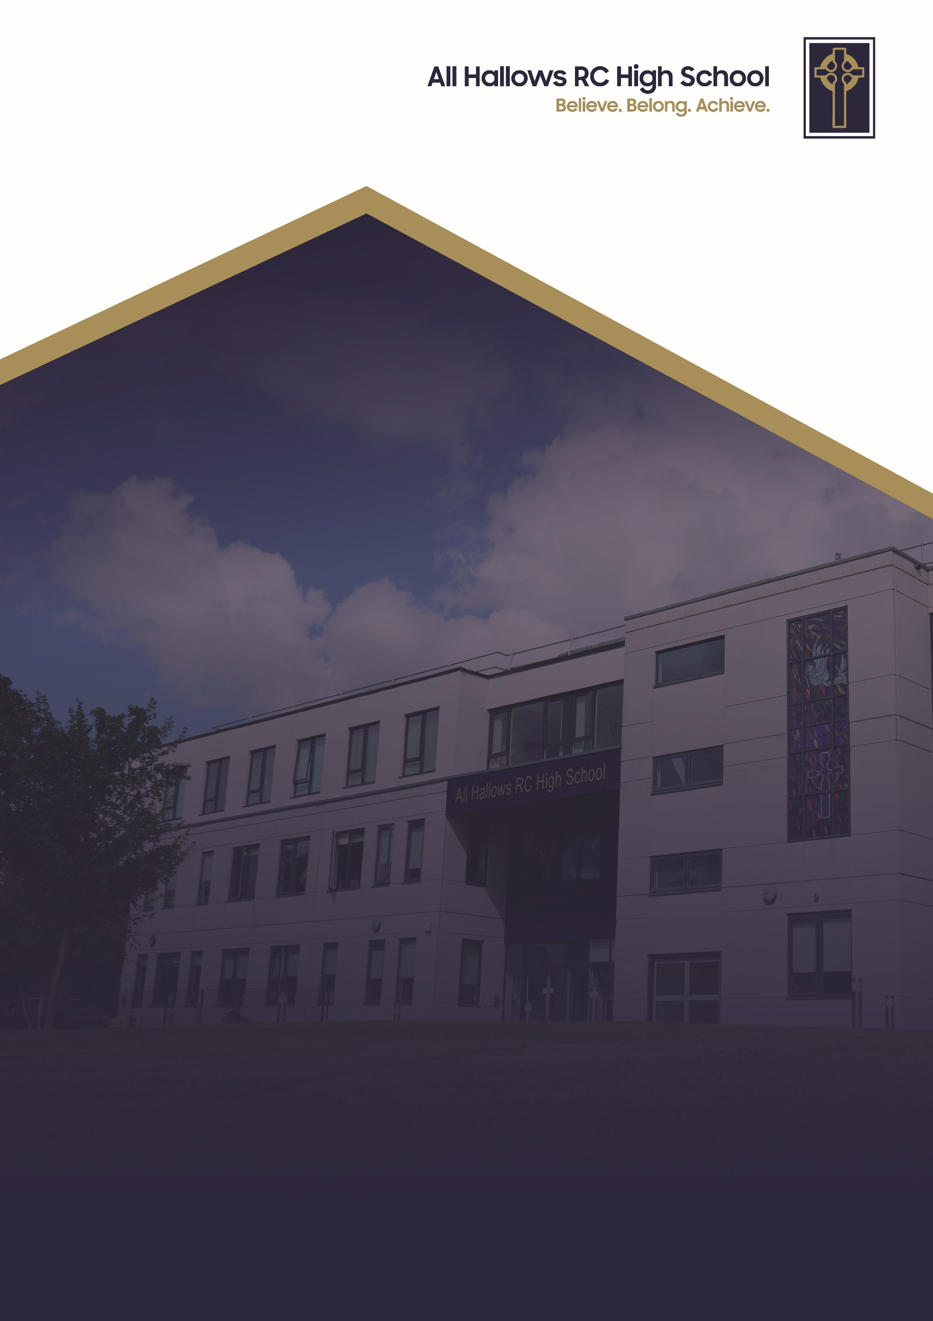
MOBILE PHONE POLICY

Committee Responsible for Review: Welfare Committee
Review Date: April 2026
Date of Next Review: April 2029



At All Hallows RC High School, we are a Christ-centred community committed to living out the Gospel values in every aspect of our school life. Our school mission is to inspire, support and challenge every member of our school. We believe that every person is created in the image of God and that they grow in faith guided by the teachings of Christ. We strive to foster an environment where love, peace, courage, justice and kindness guide our actions so we develop into compassionate, resilient individuals who contribute positively to the world around them.

We are a community built on love, demonstrating unconditional respect and kindness for all. By fostering strong relationships, we ensure that every individual feels that they belong, are valued, supported and accepted as part of our family. We celebrate our differences and each person’s uniqueness. We encourage forgiveness and understanding to create an environment where every pupil can flourish in their own way.

Through these values, All Hallows RC High School nurtures the whole person spiritually, academically and socially so they can achieve. We are a school where the Gospel values are not just ideals but the foundation of everything we do. With Christ at the centre, we enrich the lives of our pupils and guide them on the path of faith, purpose and integrity.

Mobile Phone Policy
At All Hallows RC High School our primary commitment is to foster a safe, focused, and inclusive environment where every pupil can excel academically and thrive socially. In an increasingly connected world, smart devices offer immense value, but if pupils have unrestricted presence during the school day it poses significant challenges to learning, face-to-face interaction, and mental well-being.
To ensure our classrooms remain spaces of active engagement and our communal areas promote positive, real-world connection, All Hallows RC High School operates a "Phone-Free School Day" using a daily locked pouch system.
Under this policy, all pupils keep their mobile phones safely on their person, but locked within a specialised pouch from the moment registration begins until the final bell rings. This system strikes a vital balance: pupils retain possession of their property for safety on their journeys to and from school, while the learning environment remains completely free from digital distraction, cyber bullying, and un-consented recording.
By establishing clear, physical boundaries around screen time, we empower our pupils to focus on their studies, build stronger interpersonal relationships, and enjoy a healthy digital detox throughout the school day.
Daily Operating Procedures
1. Morning Collection & Form Group Identification
- Box Retrieval: At the start of the day, form tutors must collect their designated phone pouch box from the storage unit located next to the store room, under the Heller-Up stairs on the toilet corridor.
- Form Group Codes: Each form group is allocated a year group letter eg. 7A, B, &C etc
- Pupil Numbering: Pupils are assigned a number based on alphabetical order, listed on a spreadsheet on the Google Drive. In-year admissions receive the next available sequential number.
2. Registration Routine (8:30 AM – 8:55 AM)
- Distribution: Phone pouches must be placed on desks at the start of registration with the corresponding pupil number. Form tutors may appoint a pupil monitor for this task.
- Locking Procedure: Pupils place their powered-off phone inside the pouch, lock it, and keep it on their desk. The form tutor verifies all pouches are locked before pupils place them into their school bags.
- Non-Phone Record: Tutors must record any pupil claiming not to bring a phone on the record sheet in the Google Drive.
- Box Collection: At 8:55 AM, the box containing the remaining phone pouches must be placed in the nearest open area outside the form room (a pupil monitor may assist). Boxes will be collected during Period 1 by the site team and returned to the main storage unit.

3. Assemblies, Late Arrivals, & Special Circumstances
- Assembly Days: Tutors must carry the box outside, hand out pouches, and ensure phones are locked away before pupils enter the performance area.
- Late Arrivals (Post-8:55 AM): Late pupils must check in at reception, where they will be issued a separate phone pouch and this will be logged.
- Bosco Centre, Reflection, & Medical Access: Pupils in Bosco Centre or Reflection receive specific designated pouches. Pupils requiring continuous phone access for evidential medical reasons where it is required to maintain signal and access will be permitted to have their mobile phone on their person but are informed that if they use their phone for any other reason they will receive a severe sanction for failing to follow the mobile phone policy.
4. End of Day Routine (3:00 PM)
- Unlocking: Pupils use the magnetic unlocking stations at the front of the school to retrieve their phones and post their empty pouches into their designated year group bin.
- Clubs & Period 7: Pupils attending after-school sessions must go outside at the end of Lesson 6, unlock their phone, drop their pouch in the year group bin, and return to school. The phone must remain in their bag; club leaders may request phones be placed in a central storage box during the activity.
- Detentions: Pupils in detention keep their phone locked until 3:30 PM. The reception team or a member of SLT will unlock pouches at reception, place the empty pouches in a box, and return them to the correct form group boxes.
- Pupils MUST NOT take their mobile phone pouch home; it must remain on the school premises.
5. Processing, Monitoring, & Sanctions
- Daily Box Sorting: Between 3:00pm and 3:20pm, a team of pupil volunteers (supported by teaching assistants) sort empty pouches back into form boxes on a rota basis.
- Random Audits: SLT and Heads of Year (HOYs) will review the non-phone registry daily and conduct random checks to prevent non-compliance.
- Pre-Registration Sightings: Any pupil seen with an unpouched phone before registration (prior to 8:30 AM) will receive an OOLC3 from duty staff.
- In-School Infringements: Any pupil found with an unpouched mobile phone on their person between 8:30 AM and 3:00 PM will face escalated, severe sanctions.
- Intentional damage or graffitti: Any pupil that intentionally damages their phone pouches of adds graffiti will be issued a severe sanction.
- Sabotage: Any pupil found to have sabotaged the mobile phone policy and not adhering to expectations eg. bringing two phones to school, hiding a mobile phone on school premises etc, will be issued a severe sanction.
Sanctions for non-compliance of the mobile phone policy are non-prescriptive, determined on a case-by-case basis to ensure they are proportionate to the severity of the breach and consistent with outcomes applied to other pupils

