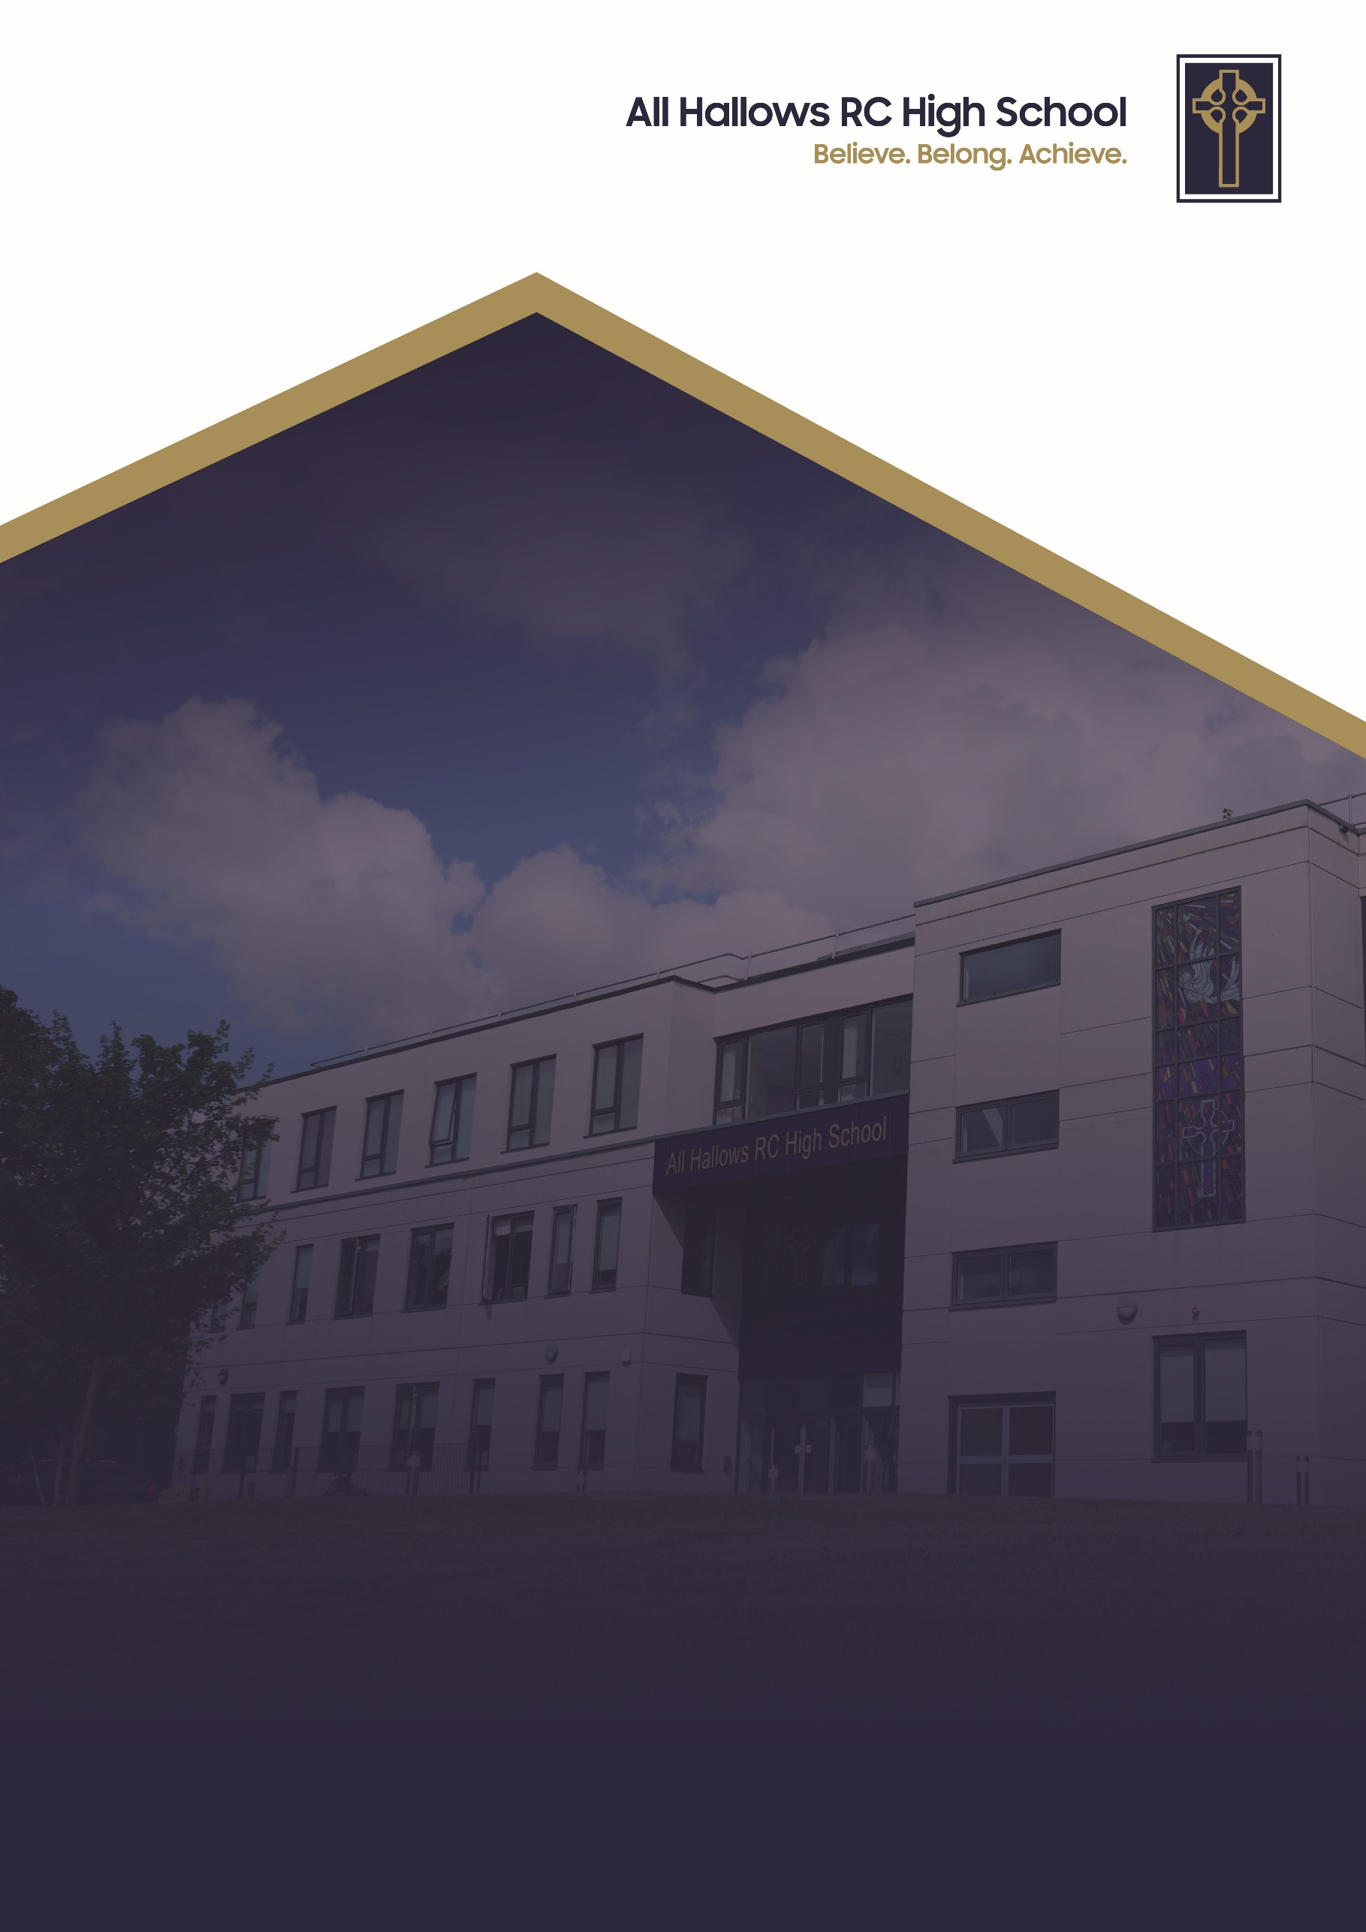
EQUALITY SCHEME POLICY

Committee Responsible for Review: Welfare Committee
Review Date: October 2026
Date of Next Review: October 2029

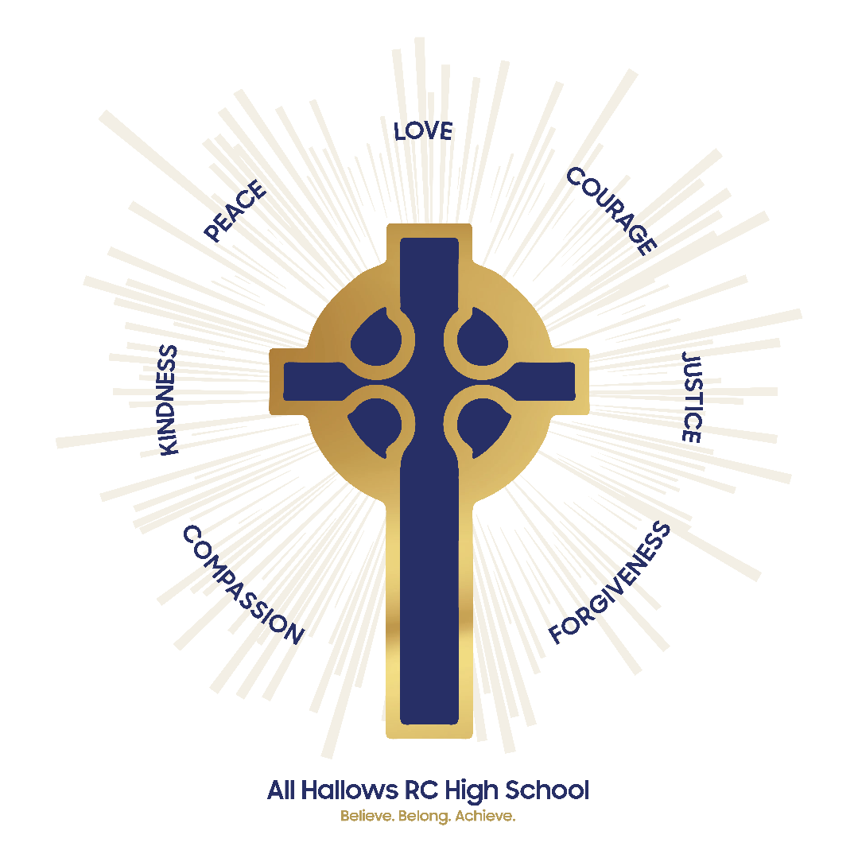

At All Hallows RC High School, we are a Christ-centred community committed to living out the Gospel values in every aspect of our school life. Our school mission is to inspire, support and challenge every member of our school. We believe that every person is created in the image of God and that they grow in faith guided by the teachings of Christ. We strive to foster an environment where love, peace, courage, justice and kindness guide our actions so we develop into compassionate, resilient individuals who contribute positively to the world around them.

We are a community built on love, demonstrating unconditional respect and kindness for all. By fostering strong relationships, we ensure that every individual feels that they belong, are valued, supported and accepted as part of our family. We celebrate our differences and each person’s uniqueness. We encourage forgiveness and understanding to create an environment where every pupil can flourish in their own way.

Through these values, All Hallows RC High School nurtures the whole person spiritually, academically and socially so they can achieve. We are a school where the Gospel values are not just ideals but the foundation of everything we do. With Christ at the centre, we enrich the lives of our pupils and guide them on the path of faith, purpose and integrity.

EQUALITY SCHEME

Contents Page

- Foreword
- Introduction
- School Values, Ethos/Mission Statement
- School Profile
- Equalities Objectives
- Accessibility Action Plan
- Community Cohesion
- Engagement and Involvement
- Procurement and Commissioning
- Roles and responsibilities for implementing the Single Equality Scheme
- Feedback and Complaints

1. Foreword
We all have an ethnicity, an age, a sexual orientation, a sex or gender identity. Many of us belong to a faith group, and an increasing number of us recognise that we have a disability or additional needs. These factors mean we each have distinct experiences, needs, and perspectives. When we speak of equality, fairness, respect, and dignity, we are talking about an agenda that encompasses every single member of our school community. At All Hallows RC High School, our core vision is simple: Believe, Belong, Achieve. Our ultimate aim is to ensure every individual feels a true sense of belonging.
Rooted in our Catholic values and ethos, we work proactively to address inequalities and improve lives for good. This is especially vital in education, where our teaching, support, and interventions shape young people for the rest of their lives—empowering them to believe in their capabilities and achieve their fullest potential.
This Single Equality Scheme sets out All Hallows RC High School’s overall commitment to equality, diversity, human rights, and community cohesion—principles that permeate all our policies and procedures. It ensures that everyone who comes into contact with our school community is valued, protected, and respected.
The scheme aims to promote equality of opportunity and eliminate unlawful discrimination, harassment, or victimisation across all protected characteristics identified by the Equality Act 2010. It details our specific equality objectives and outlines how we embed these principles into daily school life.
Our scheme encompasses our entire school community: pupils, staff, governors, parents and carers, as well as our extended partners and local community.
While this document fulfills our statutory duties under the Public Sector Equality Duty, its primary purpose is to keep All Hallows RC High School a fair, respectful, and supportive environment where every individual can flourish.

2. Introduction

The role of this Single Equality Scheme is to clearly set out our priorities for action that improve life chances, choices, and outcomes for all groups of people, and to establish clear measures to track our progress. The Equality Act 2010 protects individuals from discrimination, harassment, and victimisation across nine protected characteristics:
- Age (for staff)
- Disability
- Gender reassignment
- Marriage and civil partnership (for staff)
- Pregnancy and maternity
- Race
- Religion or belief
- Sex
- Sexual orientation.
We recognise the complexity of multiple identities and the resulting multiple needs and disadvantages that individuals may face. Our scheme sets out our priorities and actions to eliminate discrimination and harassment related to these protected characteristics, while actively promoting a culture of human rights, respect, and dignity.

These legal duties apply to staff, pupils, and anyone using the services of the school, including parents and the wider community. In accordance with the Public Sector Equality Duty (PSED), All Hallows RC High School is committed to:
- Eliminating discrimination, harassment, victimisation, and any other conduct prohibited by or under the Equality Act 2010;
- Advancing equality of opportunity between persons who share a relevant protected characteristic and persons who do not share it;
- Fostering good relations between persons who share a relevant protected characteristic and persons who do not share it.
To fulfil these aims, the school formulates, publishes, and routinely reviews specific equality objectives.
This document is aligned with and meets the requirements of the following statutory legislation and guidance:
- The Equality Act 2010, which introduced the Public Sector Equality Duty (PSED) and protects individuals from discrimination.
- The Equality Act 2010 (Specific Duties) Regulations 2011, which require schools to publish equality information annually to demonstrate PSED compliance and to publish measurable equality objectives at least every four years.
- Department for Education (DfE) non-statutory guidance: The Equality Act 2010 and schools.

3. School Values, Ethos/Mission Statement
We aim for All Hallows RC High School to be a Catholic school to which children wish to come, to which parents wish to send their children, and where teachers wish to teach. Underpinned by our core values to Believe, Belong, Achieve, our Mission is to offer a high-quality Catholic education for all, in an environment where Gospel values are central to teaching and learning, and in which the unique value of each person is recognised and respected.
Gospel values reflect what Jesus said, what Jesus did, and what Jesus told us to do. Therefore, we commit to:
- Providing a safe, supportive, and pleasant environment with a warm and welcoming atmosphere where all are supported, valued, and respected.
- Living the Gospel values of life and truth, love and service, justice and peace, forgiveness and reconciliation.
- Providing a personalised curriculum with the highest quality of learning and teaching.
- Equipping pupils for life-long learning and enabling them to develop their full potential and sense of self-worth in preparation for their journey of life, knowing that God walks with them each step of the way (Believe and Achieve).
- Recognising that everyone is unique and celebrating their differences.
- Creating a community which promotes tolerance, respect, and sensitivity to the needs of others, helping pupils understand their duties and responsibilities to their neighbour as well as their personal rights and freedoms (Belong).
Through these Gospel values, we aspire for all members of our school family to feel a deep sense of belonging and to be empowered to bring about positive change in our communities. We integrate diversity, equity, inclusion, and fairness into all aspects of school life, creating a fully inclusive environment free of discrimination, harassment, bullying, and victimisation. We promote dignity and respect where individual differences are recognised and celebrated, ensuring all staff and pupils feel supported to give their best every day. We will not tolerate any discriminatory conduct or behaviour which compromises our school aims, approaches, or commitments to equality, diversity, and inclusion.
Our approach to equality is guided by six key principles:
- Equal Value: All members of our school community are of equal value.
- Recognising & Valuing Difference: We recognise, respect, and value differences, understanding that diversity is a strength. We take account of differences and strive to remove barriers and disadvantages that individuals may face.
- Positive Attitudes & Relationships: We actively promote positive attitudes, mutual respect, and healthy relationships between different groups and communities.
- Shared Sense of Cohesion & Belonging: We want all members of our school family to feel a true sense of belonging within the school and wider community, enabling them to participate fully in school life.
- High Expectations for All: We hold the highest expectations for all our children, believing that every pupil can make good progress and achieve their fullest potential.
- Raising Standards for the Most Vulnerable: We work to raise standards for all pupils, especially the most vulnerable, recognising that improving the quality of education for vulnerable groups raises standards across the entire school.

4. School Profile
To effectively formulate and monitor our equality objectives, it is vital to build a rich picture of our school community, enabling robust analysis of our equality strengths and challenges.
We are an 11–16 inner-city Catholic school that prioritises children living across the inner city of Salford. We have been consistently oversubscribed for the last seven years.

Key Demographic Profile
- School Roll & Resourced Provision: 782 pupils on roll, including 21 pupils within our Enhanced Resource Provision, the Aquinas Centre (supporting pupils with Moderate Learning Difficulties and Speech, Language, and Communication Needs).
- Socioeconomic Context: The school serves a community facing significant economic challenges: 38% of students reside in areas within the lowest 10% IDACI decile nationally (compared to 19% across Salford).
- Pupil Premium: 40.5% of pupils are eligible for Pupil Premium funding (compared to 26.5% nationally).
- Special Educational Needs & Disabilities (SEND): 26% (205 pupils) have identified SEND support needs. 8% (65 pupils) have an Education, Health and Care Plan (EHCP)—which is more than twice the national mainstream average and 1.3 times the overall national average (3.5% in mainstream secondary and 6% overall national).
- Ethnicity & Language: We celebrate a richly diverse community where 36% of pupils are White British, 29% are EAL, and 47 different home languages are spoken across our pupil cohort.

Culture, Belonging, and Outcomes
At All Hallows RC High School, we see our richly diverse family as one of our greatest strengths. Staff and pupils actively respect and embrace their similarities and differences. We are a strong Catholic family that reaches out beyond the school grounds into our wider community.
Our curriculum is broad and ambitious, ensuring that all pupils, including those with SEND, acquire a body of knowledge that prepares them well for their next steps in education and employment. Dedicated Personal Development time explicitly addresses core equality topics, including anti-discrimination, diversity, and human rights.
All members of our school family experience a strong sense of belonging, as evidenced by our high attendance rates, pupil and staff voice, and participation in the All Hallows Charter:
- Attendance Excellence: Whole-school attendance has remained consistently above the national average for four consecutive years across all year groups and across all key pupil cohorts (including Pupil Premium, SEN Support, and EHCP pupils).
- Pupil & Staff Voice: Pupil voice surveys confirm that pupils feel safe in school, know they have a trusted adult to speak with if worried, and feel encouraged to respect people from all backgrounds. The majority of pupils state they would recommend All Hallows to a friend.
- All Hallows Charter Representation: Staff and pupils share that the All Hallows Way Charter allows pupils to be recognised and rewarded for involvement in school life, and data demonstrates that all groups of pupils are equitably represented.
Catholic School Inspection (2026):
- "There is a strong sense of family and community that is evident in the exceptional relationships across the school. Pupils have a deep sense of belonging and are proud to be members of the ‘All Hallows Family”
- “The pastoral care for pupils at All Hallows, particularly for the most vulnerable, is outstanding. There is a culture of ‘whatever it takes’ to remove barriers, so that all pupils can achieve highly."
Ofsted Inspection Recognition (October 2022):
- "Pupils develop academically and socially at All Hallows RC High School. There is a strong family ethos."
- "Pupils’ positive and supportive relationships with each other and with staff help to cultivate an atmosphere where everyone is treated kindly and with respect. This helps pupils to feel safe and secure in school."

5. Equalities Objectives
The school is committed to promoting the welfare, dignity, and equality of all its staff, pupils, and other members of the school community. To achieve this, the school has established the following objectives:
- Curriculum Impact: Monitor changes to the curriculum to ensure they result in good outcomes for pupils in all vulnerable groups.
- Attendance Equity: Continue to improve attendance by:
  - Narrowing the attendance gap between SEND and Non SEND
  - Narrowing the attendance gap between PP and Non PP.
  - Narrowing the attendance gap between EAL and non-EAL pupils.
- Progress and Attainment: Improve progress and attainment for key groups of pupils by:
  - Narrowing the attainment gap between boys and girls.
  - Improving the attainment and progress of disadvantaged pupils (Pupil Premium).
- The All Hallows Way Charter: Continue to develop the All Hallows Way Charter by:
  - Maintaining the representation of SEND pupils in Charter Rewards.
  - Improving the number of Pupil Premium (PP) pupils achieving an award.
  - Maintaining the level of enthusiasm from pupils in Years 7 and 8 into Year 9.
- Quality Standards & Accreditation: Achieve re-accreditation in the following areas:
  - Leading Parent Partnership Award (LPPA)
  - Emotionally Friendly Status
  - Special Educational Needs Disability Inclusion Award (SENDIA)
Progress towards these equality objectives is routinely monitored by the Senior Leadership Team and reported annually to the Governing Body. Operational milestones, staff responsibilities, and success criteria for these objectives are maintained dynamically through the School Improvement Plan (SIP) and internal department quality assurance reviews.
6. Accessibility Action Plan
All Hallows RC High School is committed to providing an environment that enables full access and participation for all pupils, staff, parents, and visitors. In accordance with Schedule 10 of the Equality Act 2010, the school maintains and reviews its statutory Accessibility Plan at least every three years.
Our accessibility strategy focuses on three core statutory strands:
- Increasing Curriculum Access: Ensuring disabled pupils can fully participate in the school curriculum, supported by tailored adaptations, specialised equipment, targeted interventions (such as Lexia reading support), pupil passports, and trained Teaching Assistants.
- Improving the Physical Environment: Ensuring full physical accessibility across the school estate, including robust emergency evacuation procedures (such as Evac chairs and dedicated alert support for pupils with hearing or visual impairments), while ensuring all future site developments and building works remain fully compliant with disabled access requirements.
- Enhancing Access to Written Information: Improving the delivery of written information to pupils, parents, and carers with sensory impairments or additional language/literacy needs. This is achieved through digital platforms like Edulink, specialised staff training for visual and hearing impairments, robust primary transition procedures, and alternative formats where required.

Reasonable Adjustments & Operational Monitoring
The school continuously records, monitors, and reviews all reasonable adjustments provided for staff, pupils, governors, parents, and carers. Operational tracking, specific staff responsibilities, and short-, medium-, and long-term milestones are maintained dynamically by the SENCO and Senior Leadership Team as part of internal operational planning.

7. Community Cohesion
Under the Education and Inspections Act 2006 and the Public Sector Equality Duty (PSED), All Hallows RC High School fully embraces its statutory duty to promote community cohesion.
Rooted in Catholic Social Teaching—specifically the principles of human dignity, the common good, and loving our neighbour—and aligned with our school value to Belong, we actively foster a harmonious, inclusive environment both within school and across our wider Salford community.
We promote community cohesion by:
- Celebrating Shared Values & Diversity: Promoting activities, liturgical celebrations, and curriculum content that celebrate our shared humanity while recognizing, respecting, and learning from the diverse cultures, heritage, and faith backgrounds of all our learners and their families.
- Ensuring Inclusive Participation: Encouraging and supporting pupils and families from all ethnic, cultural, linguistic, and faith backgrounds to participate fully in all aspects of school life, including extra-curricular activities, governance, and the All Hallows Way Charter.
- Engaging with the Wider Community: Collaborating with local charities, parish communities, civic partners, and voluntary organisations in Salford to promote positive race relations, mutual understanding, and social responsibility.
- Challenging Misinformation & Prejudice: Actively countering myths, stereotypes, and misinformation that may undermine good community relations or create division.
- Educating Against Hate & Discrimination: Explicitly teaching pupils through our Personal Development curriculum, RE lessons, and assemblies about the nature and impact of hate crime, prejudice, and discrimination, reinforcing that such behaviour is strictly unacceptable and contrary to Gospel values.

8. Human Rights
All Hallows RC High School embeds human rights values, rights, and responsibilities across all aspects of school life. Grounded in Catholic Social Teaching—which affirms that every person is created in the image and likeness of God (Imago Dei) and possesses inherent, non-negotiable dignity—we uphold the standards expressed in the Human Rights Act 1998, the UN Convention on the Rights of the Child (UNCRC), and the UN Convention on the Rights of Persons with Disabilities (UNCRPD).
We demonstrate our commitment to a rights-respecting environment through:
- Ethos & Culture: Sustaining a school-wide environment built on equality, human dignity, mutual respect, non-discrimination, and active participation.
- Inclusive Governance & Voice: Promoting a participatory approach to school governance, ensuring that pupils, staff, parents, and governors are meaningfully consulted on decisions that affect them.
- Empowerment & Policy Co-Creation: Empowering pupils, teachers, support staff, and governors to participate in shaping school policies, school improvement priorities, and community initiatives.
- Student Leadership & Advocacy: Encouraging robust pupil voice through the Student Council, debate forums, and pupil-led advocacy groups that drive positive school change.
- Inclusivity & Global Solidarity: Fostering a deep sense of interconnectedness, local and global solidarity, and mutual responsibility for our global neighbours.
- Curriculum Enrichment: Delivering rich, age-appropriate learning experiences about human rights, social justice, and equality both inside and outside the classroom through Personal Development, RE, and extra-curricular opportunities.

9. Procurement & Commissioning
Under the Public Sector Equality Duty (Equality Act 2010), All Hallows RC High School ensures that external contractors, suppliers, and service providers comply with equality legislation when delivering goods, services, or works on our behalf.
Equality, non-discrimination, and accessibility standards are core evaluation criteria during all procurement, tendering, and commissioning processes (including catering, transport, site maintenance, and alternative provision).
Prior to entering into contracts, third-party providers must demonstrate robust equality policies that align with our school values, statutory duties, and commitments to reasonable adjustments.

10. Roles and responsibilities for implementing the Single Equality Scheme
The Governing Body, Headteacher, Senior Leadership Team, and Line Managers hold collective responsibility for implementing the Single Equality Scheme by setting examples, enforcing high standards of behaviour, challenging discriminatory language, and ensuring all community members are aware of this policy.

The Governing Body will:
- Designate a Lead Governor with specific oversight for the Equality Scheme.
- Ensure operational equality priorities are embedded within the School Development Plan (SDP).
- Support the Headteacher in implementing necessary equality and accessibility measures.
- Consult with parents and carers regarding the scheme and evaluate its impact regularly.

The Headteacher will:
- Ensure effective implementation, promotion, and embedding of the Equality Scheme across the school community.
- Manage day-to-day equality matters for pupils and workforce employment, providing support and monitoring with assistance from relevant external agencies.
- Monitor workforce composition and encourage staff to complete annual voluntary equalities monitoring forms to identify areas for professional development.
- Ensure all staff have access to appropriate CPD, resources, and training to support implementation of the scheme.
- Keep the Senior Leadership Team informed of developments affecting the scheme and report any incidents involving protected characteristics to the Governing Body.
- PSED Statutory Reporting & Review: Publish annual equality information detailing compliance and progress made against objectives, and formally review and update equality objectives at least every four years.

The Senior Leadership Team (SLT) will:
- Support staff in day-to-day scheme implementation and lead on disseminating guidance.
- Identify high-quality resources, CPD, and training opportunities.
- Assist the Headteacher in managing equality-related issues or incidents.
- Lead reviews of operational targets integrated within the SDP and department quality assurance processes.

All School Staff will:
- Recognise equality as a whole-school responsibility and align planning, teaching, and learning strategies accordingly.
- Teach pupils to treat everyone with dignity and respect, actively promoting the benefits of a diverse society.
- Ensure equitable access to the curriculum and extra-curricular opportunities for all pupil groups.
- Challenge bias, stereotyping, and discriminatory language or behaviour, and report incidents using established school procedures.
- Engage in relevant continuous professional development (CPD) and participate in workforce equalities monitoring.

Parents and Carers will:
- Have open access to the Equality Scheme and be encouraged to support its values.
- Have opportunities to participate in awareness-raising sessions or consultations related to equality and inclusion.
- Be informed promptly of any significant incidents relating to the scheme that directly impact their child.

Pupils will:
- Be made aware of the scheme in an age-appropriate manner and be expected to act in accordance with its values.
- Have opportunities to contribute to the review and development of the scheme through pupil voice and the All Hallows Way Charter.
- Experience a safe, respectful curriculum and environment that prepares them for life in modern Britain.

11. Information, Feedback and Complaints
All Hallows RC High School is committed to clear, transparent communication and accessible information for all members of our school community.
If you require a copy of this scheme in an alternative accessible format (such as large print, Braille, or digital translation), or if you wish to provide feedback, raise a query, or submit a complaint regarding this scheme or our equality practices, please contact us:
- Email: enquires@allhallowsrc.co.uk
- Telephone: 0161 921 1900
- Address: All Hallows RC High School, 150 Eccles Old Road, Salford, M6 8QD
Complaints regarding equality matters will be addressed in accordance with the school's formal Complaints Policy.

