
Governor Terms Of Office

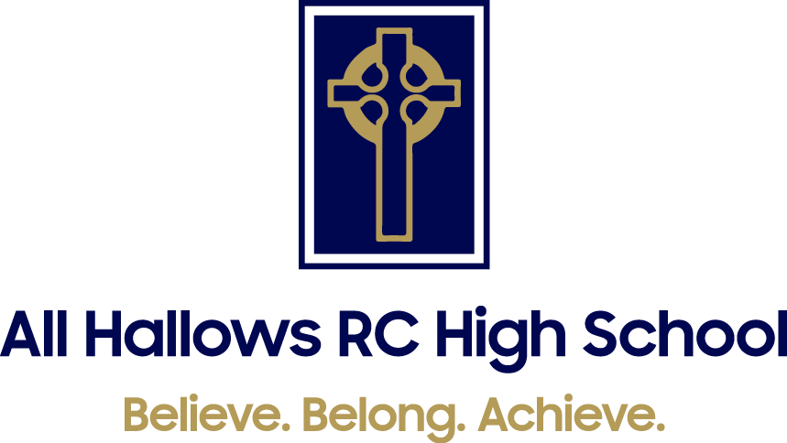

Governor Terms Of Office

Governor | Start of Term | End of Term
Mrs C Wood (Chair, Foundation) | 01/09/2025 | Resigned 14/07/2026
Mr E Sheehy (Foundation) | 26/06/2023 | 25/06/2027
Ms L Graham (Staff) | 03/03/2023 | 02/03/2027
Mr V da Silva Carvalho (Foundation) | 18/01/2023 | Resigned 14/07/2026
Mr J Humphries (LA) | 22/12/2023 | 21/12/2027
Mrs C Doyle (Foundation) | 24/10/2024 | 23/10/2028
Mrs E Walker (Headteacher) | N/A | N/A
Canon M Cooke (Foundation – Full Governor Meetings only) | 01/01/2025 | 31/12/2028
Mrs D Hanley (Foundation) | 12/12/2024 | 11/12/2028
Mr P Roebuck (Parent) | 15/01/2026 | 14/01/2030
Mrs M Mattocks (Foundation) | 02/10/2026 | 01/10/2030
Mr C Gilliver (Parent) | 13/10/2026 | 12/10/2030

