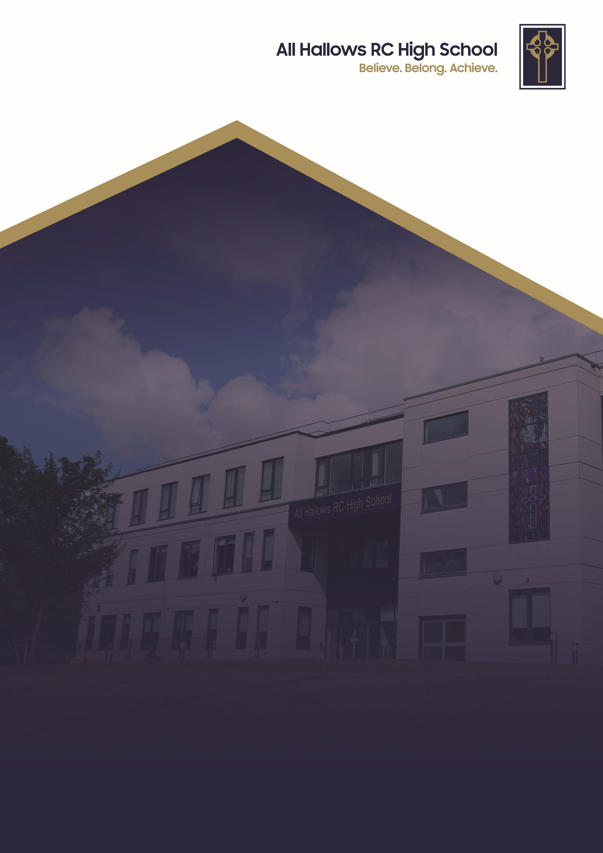
ATTENDANCE/PUNCTUALITY POLICY

Committee Responsible for Review: Welfare Committee
Review Date: September 2026
Date of Next Review: September 2028



At All Hallows RC High School, we are a Christ-centred community committed to living out the Gospel values in every aspect of our school life. Our school mission is to inspire, support and challenge every member of our school. We believe that every person is created in the image of God and that they grow in faith guided by the teachings of Christ. We strive to foster an environment where love, peace, courage, justice and kindness guide our actions so we develop into compassionate, resilient individuals who contribute positively to the world around them.

We are a community built on love, demonstrating unconditional respect and kindness for all. By fostering strong relationships, we ensure that every individual feels that they belong, are valued, supported and accepted as part of our family. We celebrate our differences and each person’s uniqueness. We encourage forgiveness and understanding to create an environment where every pupil can flourish in their own way.

Through these values, All Hallows RC High School nurtures the whole person spiritually, academically and socially so they can achieve. We are a school where the Gospel values are not just ideals but the foundation of everything we do. With Christ at the centre, we enrich the lives of our pupils and guide them on the path of faith, purpose and integrity.

ATTENDANCE POLICY / PUNCTUALITY POLICY

At All Hallows RC High School we believe in a whole school approach to attendance. This approach recognises the important role played by all school staff, pupils, parents and governors in ensuring each pupil gains his/her full educational entitlement.

This policy has been written in conjunction with the Dfe guidance “Working together to improve school attendance” July 2026

PURPOSE
- To ensure the school’s statutory, legal obligation is met.
- To promote maximum attendance by all students.
- To provide information for staff, parents, the Governing Body and employers.
- To assist in the early detection of attendance issues so that a variety of agencies can become involved.
- To ensure consistency of approach.

Mrs Done, Senior Assistant Headteacher, is the strategic lead for attendance at All Hallows. She is supported in her role by Miss Hambelton (Social Inclusion officer) and Jessica Martin (pastoral support). The Education Officer from the local authority that supports the school is Emma James.

REGISTRATION
The register is an important legal document. The school uses computerised registration and this needs to be completed carefully each day. Certain procedures are required.

- Morning Registration
This takes place at 8.30 am after which the electronic register should be saved by the form tutor.

- Afternoon Registration
This takes place at 1.20 pm during lesson 5 after which the electronic register should be saved by the class teacher.

- Class Registers
An electronic register should be completed every lesson and should be saved by the class teacher.

It is the form tutor/class teacher's responsibility to complete the register correctly before saving it electronically. This is a statutory requirement and forms part of the whole school safeguarding policy.

- Absence codes
It is the form tutor’s responsibility to complete absence codes on the electronic register. If information about an absence is received by the receptionist before or after registration from parents/guardians the appropriate entry will be made on the electronic register. Consent for absence from parents/guardians with parental responsibility must be received.

Lates
If a pupil arrives late to school for registration he/she should be marked late using the correct code on the electronic register.

All pupils arriving late in the morning are required to report to reception where a member of staff from the attendance team will mark them late if they arrive between 8.30am – 9.00 am.

If pupils arrive after 9.00am they will receive an unauthorised absence (U code) for the morning session but will be recorded as present in school by the receptionist for safety reasons. They will also receive present marks during the morning lessons for which they have attended. A U code is considered as a 1/2 day absence and impacts a pupil's overall attendance.

The receptionist will record the time of arrival on the electronic registers for form tutor and class teacher information.

Families that live a distance from school must ensure they take the appropriate travel arrangements so that the pupil can arrive to school by 8.30am.

PUNCTUALITY STRATEGY

For pupils to obtain the maximum benefit from the education provided it is necessary for them to be present for the entire day. It is important that pupils are taught that punctuality is important for future college or employment.

All Hallows runs a strict late gate. Any pupil that is late after 8.30am will be recorded on entrance to school and will be issued with a same day late detention at 3pm. Parents will be informed by text message service when pupils have been issued with a late detention.

The late detention takes place at 3pm in a classroom. During lesson 6 the pupils that are in late detention are reminded by our pastoral support worker and directed to the location of the late detention. Teaching staff supervise the late detention based on a supervision rota.
A register is taken and any pupil that does not attend the late detention is given a further sanction for defiance. Any pupil that refuses to attend late detention will be issued with a day in the school seclusion unit. If a pupil has been issued a C3 detention as well as a late detention on the same day, then the late detention will be completed at 3.30pm. This will take place following the completion of the C3 detention with a member of the senior leadership team.
Records of accrued lates are kept and monitored by form tutors/HOYs. Where pupils do not respond positively to the above sanctions the following interventions will be applied.

- If there is no improvement, form tutors will contact parents to arrange a meeting to discuss a way forward.
- If parents do not respond they will be contacted by the HOY.
- Contact from the Social Inclusion Officer to warn of fixed penalty notice and possible referral to the Attendance Officer at the Local Authority.
- Referral to the Locality Team and fixed penalty warning may be issued if lateness is beyond the close of registers.

PROMOTING ATTENDANCE
The importance of good attendance is given a high profile by:

- The importance of good attendance will be emphasised in the pupil information booklet given to Year 7 before their arrival.
- Reminding parents/guardians and pupils of our expectations regarding attendance at New Intake Evenings, Parents’ Evenings and by letter.
- Regular assemblies where good attendance will be the central theme. Good practice will also be highlighted in form groups.
- Including attendance figures for pupils on their Record of Achievement and Interim Reports.
- The work of the schools’ Social Inclusion Officer and Pastoral Support Worker, who will target pupils with attendance problems from Years 7 – 11. Their role is to focus on pupils that are persistently (>90%) and severely absent (>50%) from school.
- The school runs an inter-form attendance competition each week. There are weekly fixtures and the results and league table are published on Monday morning in form time. The winning form group at the end of every term receive a prize. In addition, there is form group competition within each year group which looks at weekly and YTD data.
- Pupils with 100% attendance at Christmas, Easter and Summer receive prizes from the Headteacher in the end of term assembly. All pupils with an attendance of 96% or above get entered into a termly prize draw; there are two prizes per year group per term.
- High attendance is a focus in The All Hallows Charter. Pupils must have good attendance as a contributing factor towards their bronze, silver or gold award.
- Individual attendance is discussed and recognised during extended tutor time on Monday mornings.

PROCEDURES FOR DEALING WITH ABSENCE
- Immediate Response
In the event of no contact from home on the first day of absence a message is sent via the school messaging system by admin staff. The receptionist or pastoral support worker will then try to contact parents or carers by telephone and record contact for form tutors on the electronic registers. If telephone contact is not possible, a home visit will be conducted to check on welfare. A letter will be sent to parents that do not regularly keep in contact with school regarding their child’s absence, this will be to emphasise their responsibility to inform school of reasons for absence.

- Authorised Absence
A person with parental responsibility must ensure that they contact the school reception on the first day of absence to explain the reason for absence. Any further days will require daily contact to keep school up to date about the absence. Pupils with an attendance below 90% will require a form of medical evidence to authorise the absence.
The Pastoral Support Officer may conduct a back to school interview with the pupil and notes will be recorded about the conversation. Any notes received from parents/guardians should be attached to the back to school interview sheet which will be filed by the pastoral support worker. If there are concerns that arise following these conversations contact will be made with the family to discuss the matter further.

No pupils may leave the school session without permission. In the case of appointments an appointment card, phone call or email from a parent or carer must be brought to school. Pupils must always sign out at the school office, collect a red card and sign back in on their return if it is the same day. Red cards must be signed by the HOY of that year group or a member of SLT. All pupil attendance and absence is monitored. Only half a day will be authorised for a medical appointment and parents are asked, where possible, to take appointments out of school hours. If any appointment requires a full day, this must be requested and medical evidence must be provided.

Pupils whose attendance begins to cause concern will be tracked and monitored by form tutors, HOYs, Social Inclusion Officer and SLT. Parents will be informed when concerns relating to attendance arises. The school wish to work with families and provide support to improve attendance. A request for external agency support via an Early Help Assessment will be offered to parents/guardians.

- Unauthorised absence
All absences that have not been sanctioned by the school (eg holidays, excessive absence without medical evidence etc) will be recorded as unauthorised. A pupil that arrives to school after 9am without a valid reason will incur 1 session of unauthorised absence. A total of ten or more unauthorised absences (there are 2 sessions per day), can lead to a fixed penalty fine. Holidays during term time are not authorised by the school.

d. Persistent and Severe Absence

Pupils with persistent absence (90% and below) will be closely monitored and issues addressed. Parents will be informed if their child has dropped into this category. All pupils that have an attendance below 90% will be notified that they require medical evidence to authorise any further absence from school. This medical evidence can be in the form of appointment cards, prescription labels, hospital letters, or time-stamped pharmacy receipts for over-the-counter medication prescription.

If no significant improvement in attendance occurs, parents may be required to come to an Attendance Panel Meeting to discuss the situation, to set formal targets and to sign a contract. The Panel will consist of the Social Inclusion Officer, the pupil, parent/carer and, where appropriate, an Attendance Officer from the Local Authority. Failure to attend the meeting may result in further action being taken by the Local Authority. If poor attendance continues i.e. 10 unauthorised sessions of absence (2 sessions in a day) fixed term penalty process or fast track process will be actioned.

Particular focus is given by school and other external agencies that are involved to pupils who are absent from school more than they are present (those missing 50% or more of school). We recognise that these severely absent pupils may find it more difficult to be in school and face bigger barriers to their regular attendance and as such are likely to need more intensive support across a range of partner agencies. If all avenues of support have been facilitated by school and partner agencies, and the appropriate educational support has been offered but severe absence for unauthorised reasons continues, it is likely to constitute neglect. All Hallows is especially conscious of any potential safeguarding issues in these cases and where these remain, a full children’s social care assessment will be conducted by the Local Authority.

ABSENCE LEADING UP TO AND AFTER A SCHOOL HOLIDAY

Absences in the last three days leading to the end of term and the first three days of a new term will not be authorised without medical evidence. This is to ensure consistency in our approach to dealing with unauthorised holidays in term time.

THE EDUCATION PENALTY NOTICE REGULATIONS

There is a single National Threshold for when a penalty notice must be considered by schools of 10 unauthorised absence (5 days) within a rolling 10 week period. The sessions do not have to be consecutive and can be made up of any type of unauthorised absence.

The first time a penalty notice is issued for unauthorised absence the amount will be £160 per parent, per child. This fine will be discounted to £80 if paid within 21 days. The second time a penalty notice is issued for unauthorised absence (within 3 years) the amount will be £160 per parent, per child paid within 28 days. This fine will receive no discounted rate.

Should a third absence be taken within the three year period, a parent may be summoned to the Magistrates Court for knowingly failing to secure good attendance at school (Section 444 (1A) of Education Act 1996).

BARRIERS TO SCHOOL ATTENDANCE (BtSA)
The WARMTH Framework and the Early Identification of Needs Tool (EINT) are core components of Salford's local approach to supporting children experiencing difficulties with school attendance (historically referred to as Emotionally Based School Avoidance or EBSA). All Hallows RC High School work with pupils and families under this framework.
Together, they form a non-punitive, trauma-informed model designed to help the school, families, and pupils identify barriers to education early and provide collaborative support.

1. The WARMTH Framework
Developed through consultation with over 1,500 stakeholders, WARMTH is a guiding ethos and practice framework built on six key principles:
- W – Wellbeing First: Prioritising a child's mental health, safety, and sense of belonging over attendance numbers. Increased attendance is viewed as a byproduct of improved wellbeing.
- A – Affirming Practice: Accepting and respecting neurodiversity and individual differences to ensure equity rather than forcing compliance.
- R – Relational Approach: Focusing on strong, trusting relationships between staff, pupils, and parents to uncover the underlying root causes of behaviours.
- M – Mutual Understanding & Partnership: Working with families and young people as equal partners, listening actively to their lived experience.
- T – Timely Response: Intervening at the earliest sign of distress or difficulty before attendance issues become deeply ingrained or lead to burnout.
- H – Holistic Support: Looking at all aspects of a child's life—academic, social, sensory, family, and transport barriers—rather than focusing solely on what happens inside the classroom.

2. Early Identification of Needs Tool (EINT)
The EINT is the practical, operational tool used by schools to put the WARMTH principles into action.
- Collaborative Assessment: It is a structured questionnaire and planning resource completed jointly by school staff, parents/carers, and the young person.
- Holistic Profiling: Instead of simply tracking missed days, the EINT systematically screens for barriers across multiple domains—such as hidden neurodivergent traits, anxiety, social conflict, sensory overwhelm, or home/family factors.
- Targeted Action Plans: The outputs from the EINT directly inform a personalised support plan featuring reasonable adjustments, environmental adaptations, and relational support strategies, which are then reviewed regularly.

How They Work Together
Instead of treating school absence as a disciplinary issue, Salford schools use the EINT to catch early distress and apply the WARMTH Framework to adapt the environment and rebuild trust. The ultimate goal is to remove the underlying barriers so the child feels safe enough to re-engage with education.

REINTEGRATION OF LONG TERM ABSENTEES
The school will work together with the families and relevant external agencies to develop a planned programme to reintegrate the long term absentee back into school. The reintegration of pupils involves a co-ordinated effort between school, parents/carers, pupil any other agencies which have been involved with the pupil.

In meeting the individual needs of long term absentees, it may involve a phased, part-time timetable with support provided by SENCO, HOY and the form tutor who will regularly review the programme with parents/carers and pupils. In some instances the pupil may spend time in the Curriculum Access Unit (CAU), the Lourdes Centre or Bosco Centre prior to reintegration.

All staff will be made aware of the return of long term absentees through pastoral and staff briefings so that they can encourage a supportive positive environment for their return.

Where appropriate, pastoral staff or the Social Inclusion Officer may visit absentees at home to encourage pupils to return to school after a long period of absence.

Pupils who have been absent from school for a long period of time will need a support structure to help them reintegrate and special help to cope with academic work. Long term absentees will be monitored by form tutors who will be able to offer daily contact and support to the pupil.

PASTORAL BRIEFING
There is a weekly pastoral briefing where staff are informed of any relevant pastoral information. Staff are informed of whole school attendance data and any actions required. A weekly update is provided on the attendance league and year group league, which also appears on the All Hallows Charter Presentation. This information is shared with pupils during the extended form tutor period on Monday morning.

HOYs and Form Tutors will liaise with the attendance team to discuss individual pupils whose attendance is causing concern and the appropriate course of action taken.

Monitoring Attendance and Identifying Patterns

In line with the Department for Education’s statutory guidance Working Together to Improve School Attendance 2026, the school systematically monitors and analyses attendance and punctuality data to identify patterns, emerging risks, and barriers to education as early as possible. Registration data is reviewed on a daily, weekly, and half-termly basis using our Management Information Systems

The attendance team regularly evaluates trends across individual pupils, year groups, and specific demographic cohorts (including pupils with SEND, those facing emotional barriers, and young carers). By conducting regular data sweeps, we can differentiate between occasional lateness and entrenched patterns of non-attendance, triggering early, supportive interventions—such as tutor check-ins, attendance action plans, or multi-agency meetings—before absence reaches persistent or severe thresholds.

To ensure proactive and timely support for all pupils, All Hallows utilises the Department for Education’s (DfE) secure View Your Education Data (VYED) service—specifically the Monitor Your School Attendance tool. Through automated daily data exchanges between our Management Information System (MIS) and the DfE, the attendance lead uses this platform to analyse real-time attendance trends, monitor persistent and severe absence risk factors, and identify emerging patterns across specific year groups, demographic cohorts, and individual pupils.

