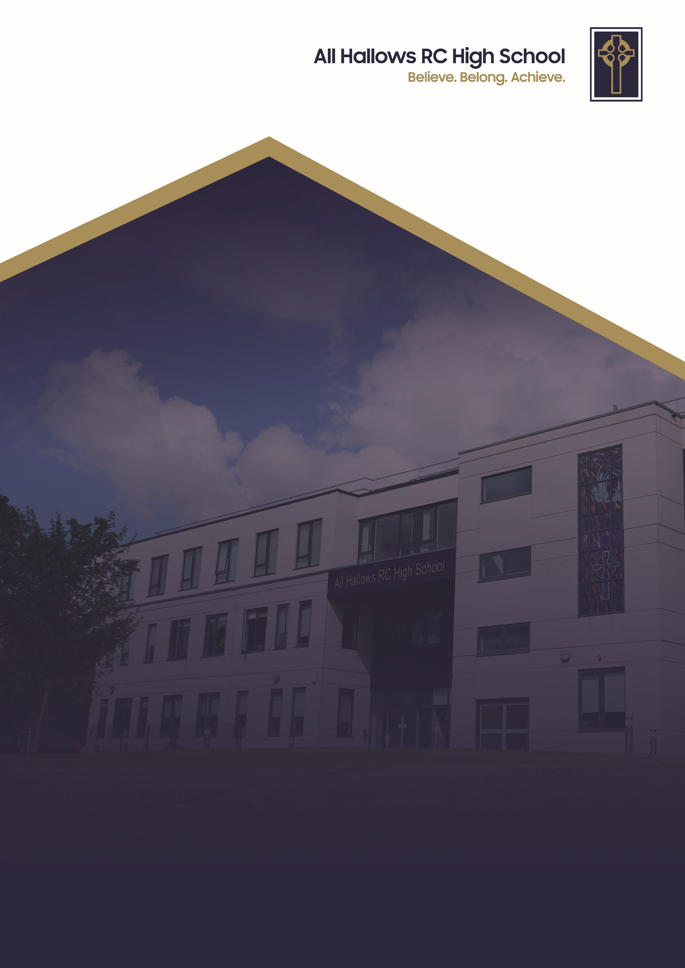
UNIFORM POLICY

Committee Responsible for Review: Welfare Committee
Review Date: September 2025
Date of Next Review: September 2028

UNIFORM POLICY

At All Hallows RC High School, we are a Christ-centred community committed to living out the Gospel values in every aspect of our school life. Our school mission is to inspire, support and challenge every member of our school. We believe that every person is created in the image of God and that they grow in faith guided by the teachings of Christ. We strive to foster an environment where love, peace, courage, justice and kindness guide our actions so we develop into compassionate, resilient individuals who contribute positively to the world around them.
We are a community built on love, demonstrating unconditional respect and kindness for all. By fostering strong relationships, we ensure that every individual feels that they belong, are valued, supported and accepted as part of our family. We celebrate our differences and each person’s uniqueness. We encourage forgiveness and understanding to create an environment where every pupil can flourish in their own way.
Through these values, All Hallows RC High School nurtures the whole person spiritually, academically and socially so they can achieve. We are a school where the Gospel values are not just ideals but the foundation of everything we do. With Christ at the centre, we enrich the lives of our pupils and guide them on the path of faith, purpose and integrity.

Principles

High standards of behaviour, appearance and achievement are expected of all pupils, to secure the effective delivery of teaching and learning, the promotion of cohesion and good order in the school, the prevention of bullying and for health and safety considerations. Pupils are expected to attend school appropriately dressed and equipped ready to access the learning opportunities provided. We want pupils to feel smart and to be proud to be part of our All Hallows family – the correct wearing of our uniform is an outward sign of this; it also indicates that pupils are in the right mind set for learning.

School uniform consists of:-

School blazer ]
School jumper ] available from Whittakers (formerly Wilkinson’s), opposite Swinton Civic Centre
School tie ]
White school shirt
Black knee length pleated skirt / black tailored trousers
Black or white ankle socks or plain black tights (please note tights and socks cannot be worn together)
Plain black school shoes – no trainers / canvas / sports shoes

In colder weather, a blue or black coat may be worn over the full uniform. The wearing of tracksuit tops and sweatshirts (with or without a hood) are not allowed.

All items of uniform must be worn every day and it is advisable that all items are marked with the pupils’ name. The wearing of the school jumper may become optional during the warmer months at the discretion of and notification by the Headteacher.
Jewellery: Earrings are not permitted to be worn, this includes clear studs or plasters over piercings. The only jewellery that is allowed to be worn is be a plain watch. Please be reminded that smart watches (like mobile phones) are banned from school.
Hair must be conservative in style and colour. Hair bands must be plain navy blue or black. Make up: must not be worn. This includes any type of nail varnish, acrylic nails, false eyelashes and/or false tan. Pupils may wear a small amount of concealer as long as it is subtle, particularly to address blemishes or skin issues about which children may feel self-conscious. Please note that coloured blemish stickers are not permitted.

Equipment – all pupils must bring a school bag which must be large enough to carry an A4 folder, exercise books, planner and pencil case.

PE Kit – Polo shirt with school logo ] Available from Whittakers
Blue shorts (school issue) ] (First PE kit – September Y7 - Free
Socks ]

Sanctions

It is expected that all pupils wear all items of uniform. If any pupil chooses to attend school not wearing the specified uniform, the following sanctions will be applied:

- Pupils will be asked to remove any item of clothing/ jewellery/ fashion accessory which does not comply with the uniform policy. These will be retained for safekeeping by a member of staff and can be collected at 3pm on that day.
- Pupils will be loaned items of uniform that they may have missing and their Respect card will be signed.
- Pupils with incorrect footwear will be expected to loan a pair of shoes from school.
- Where a pupil refuses to comply with uniform policy (including wearing correct footwear), the result could lead to a pupil being placed in the seclusion unit until the matter is resolved, being sent home to change and in extreme cases, suspension from school. Also, parents could be asked to come into school to discuss the pupils’ non-compliance with school policy.

The school is sensitive and supportive of exceptional circumstances where a pupil is not adhering to school uniform policy. If this is the case, parents are asked to provide a written note with details of the uniform infringement and when it will be resolved.

Mobile phones and airpods are not permitted and pupils that are seen or heard with these items will be asked to give them to a member of staff. These items can be collected at 3pm from reception. Refusal to comply with this request will lead to an escalation in sanctions but no pupil will be permitted to remain on the school premises if they have refused to hand their mobile phone or airpods to a senior member of staff; this could therefore lead to a suspension from school.

All members of staff are expected to apply sanctions.

We reserve the right to respond to and address any unanticipated fashion trends.

