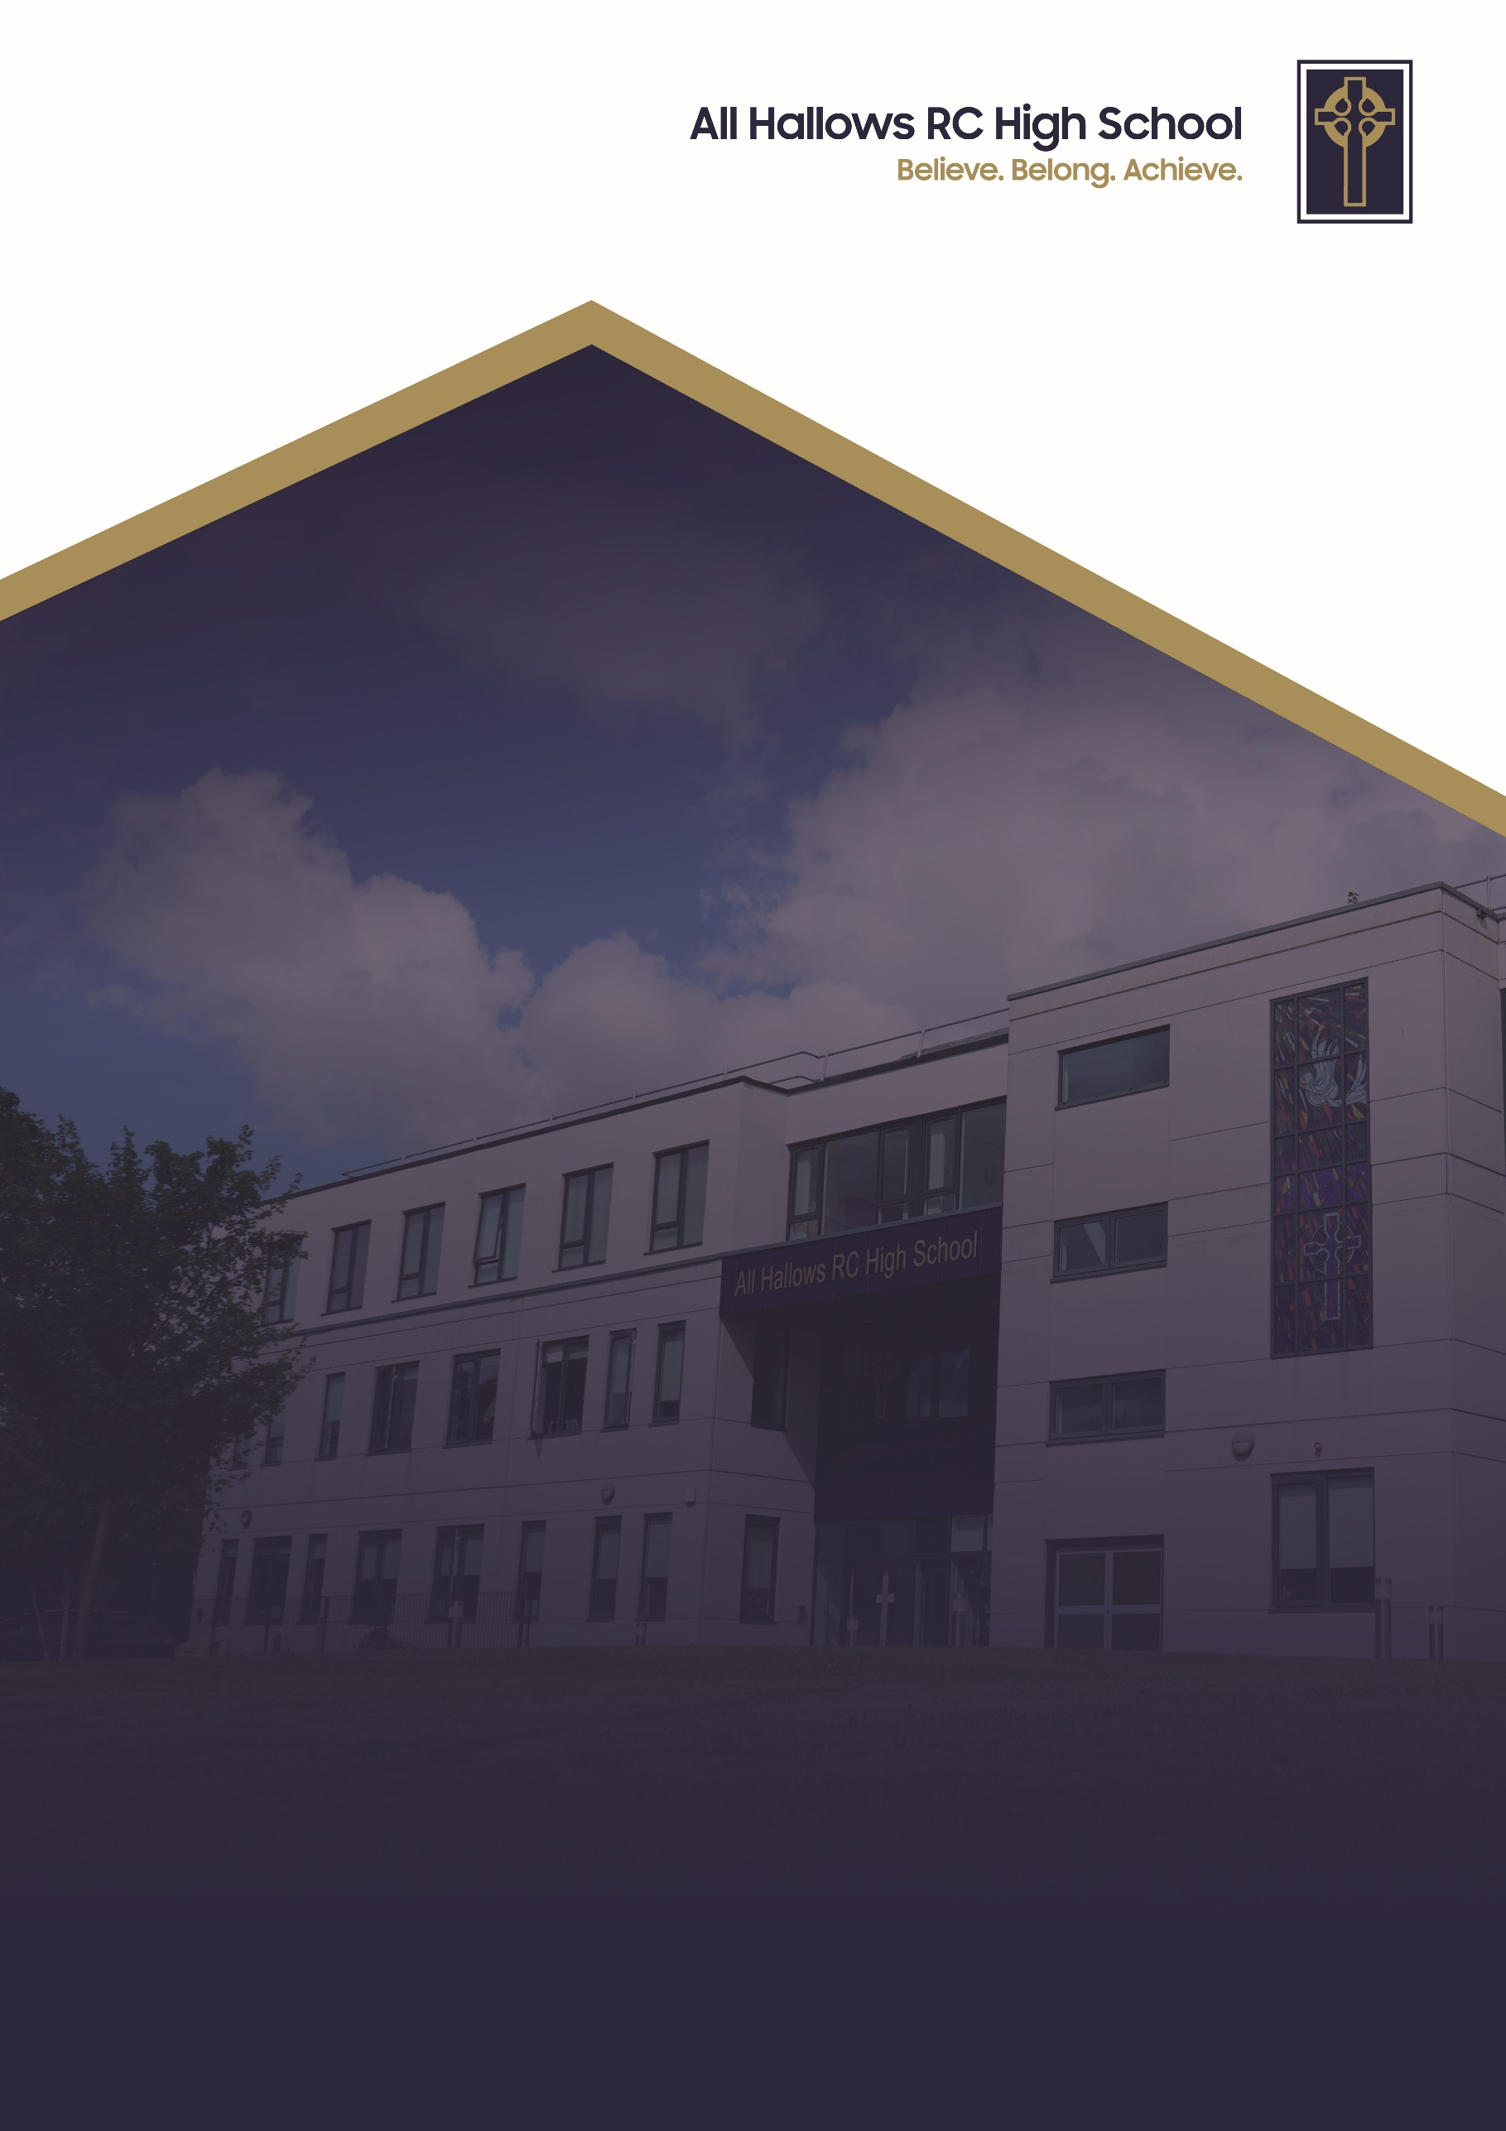
CHILD PROTECTION AND SAFEGUARDING POLICY

Committee Responsible for Review: Welfare Committee
Review Date: September 2026
Date of Next Review: September 2027

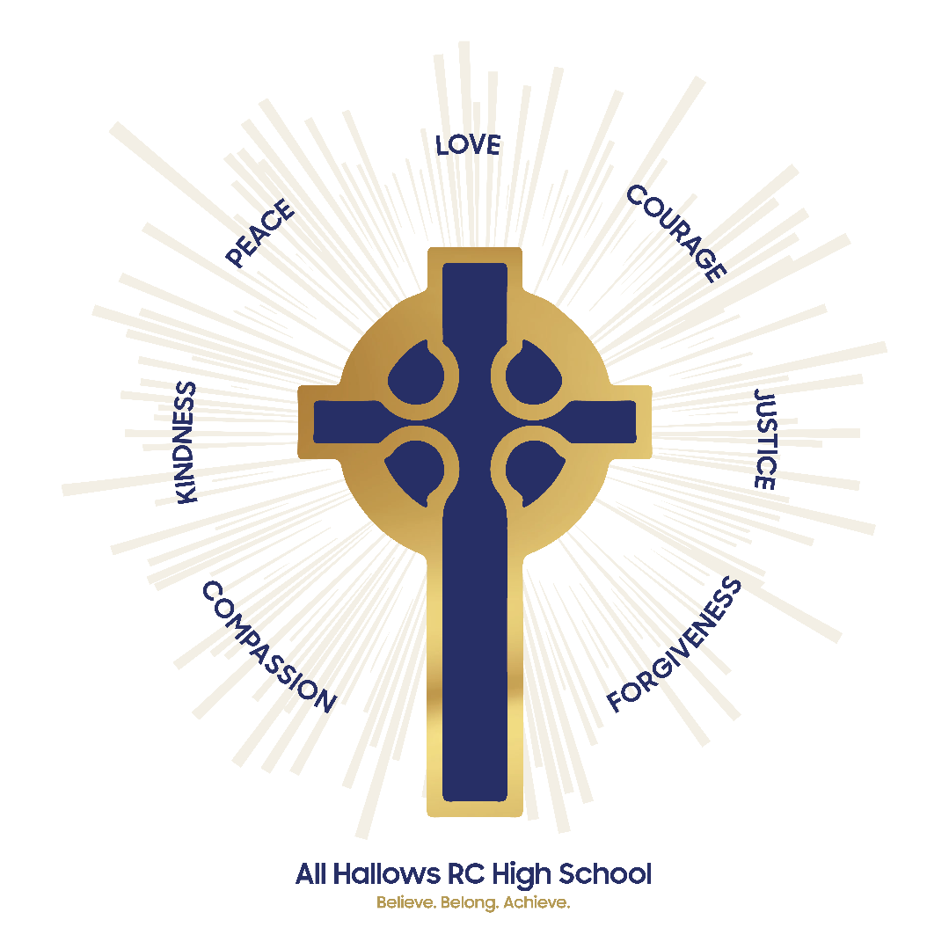

At All Hallows RC High School, we are a Christ-centred community committed to living out the Gospel values in every aspect of our school life. Our school mission is to inspire, support and challenge every member of our school. We believe that every person is created in the image of God and that they grow in faith guided by the teachings of Christ. We strive to foster an environment where love, peace, courage, justice and kindness guide our actions so we develop into compassionate, resilient individuals who contribute positively to the world around them.

We are a community built on love, demonstrating unconditional respect and kindness for all. By fostering strong relationships, we ensure that every individual feels that they belong, are valued, supported and accepted as part of our family. We celebrate our differences and each person’s uniqueness. We encourage forgiveness and understanding to create an environment where every pupil can flourish in their own way.

Through these values, All Hallows RC High School nurtures the whole person spiritually, academically and socially so they can achieve. We are a school where the Gospel values are not just ideals but the foundation of everything we do. With Christ at the centre, we enrich the lives of our pupils and guide them on the path of faith, purpose and integrity.

CHILD PROTECTION AND SAFEGUARDING POLICY

This policy should be read in conjunction with:

“Keeping Children Safe in Education” 1st September 2026 which is the statutory guidance for Schools and Colleges.

‘Working Together to Safeguard Children’ (2026) which is statutory guidance to be read and followed by all those providing services for children and families, including those in education.

“Information Sharing: Advice for practitioners providing safeguarding services to children, young people, parents and carers (May 2024)

“The Prevent Duty Departmental, advice for Schools and child care providers” (March 2015) updated March 2024

Purpose
This policy reflects our active commitment to promote and safeguard the welfare of pupils at our school. We believe that children have a fundamental right to feel safe and protected from any form of abuse. Therefore we aim to provide a secure, caring environment, highly skilled and aware staff, and a curriculum which promotes self-esteem, nurtures well-being and empowers children to protect themselves.

This policy should be considered alongside school child protection procedures (Appendix 3) and other related policies in school.

Safeguarding and promoting the welfare of children is everyone’s responsibility. Everyone who comes into contact with children and their families and carers has a role to play in safeguarding children. In order to fulfil this responsibility effectively, all staff at All Hallows should make sure their approach is child-centred. This means that they should consider, at all times, what is in the best interests of the child.
At All Hallows we are committed to safeguarding children and young people and we expect everyone who works in our school to share this commitment.
Adults in our school take all welfare concerns seriously and encourage children and young people to talk to us about anything that worries them.

We aim to ensure that children who are vulnerable, at risk and have suffered or are likely to suffer significant harm are identified, and appropriate action is taken to keep them safe. All Hallows has and will continue to develop a systematic approach towards identification and referral of suspected child abuse to an appropriate agency. We recognise that abuse may be emotional, physical, sexual or through neglect.

We know that being a young person makes them potentially vulnerable to abuse by adults. We aim to make sure that the actions of any adult in the context of the work carried out by the school and associated organisations are transparent, that they safeguard and promote the welfare of all young people. Furthermore, at All Hallows we ensure that all staff are competent and confident in carrying out their responsibilities for safeguarding and promoting children’s welfare.

At All Hallows pupils are taught about safeguarding, including online, through various teaching and learning opportunities, as part of providing a broad and balanced curriculum. Pupils are taught how to recognise when they are at risk and how to get help when they need it.

This document is written in accordance with the Local Safeguarding Children Board Policy and ‘Working Together to Safeguard Children’ 2026 and ‘Keeping Children Safe in Education’ 2026.

The definition of safeguarding and promoting the welfare of children:
The definition used in the Children Act of 2004 and the DfES guidance document ‘Working together to Safeguard Children’ (2023) which focuses on safeguarding and promoting children and young people’s welfare can be summarised as:
- Protecting children from maltreatment
- Preventing impairment of children’s health or development
- Ensuring that children are growing up in circumstances consistent with the provision of safe and effective care, and
- Taking action to enable all children to have the best outcomes.
- providing help and support to meet the needs of children as soon as problems emerge
- protecting children from maltreatment, inside or outside the home, including online.
Principles (upon which this is based).

- The welfare of a child or young person will always be paramount.
- The welfare of families will be promoted.
- The rights, wishes and feelings of children, young people and their families will be respected and listened to.
- Keeping children safe from harm requires people who work with children to share information.
- Those people in positions of responsibility within the organisation will work in accordance with the interests of children and young people and follow the policy outlined below.

Safeguarding and child protection is at the core of what we do and consider it to be the responsibility of all staff. This means thinking about and including issues to do with child protection and safeguarding and promoting the welfare of children at all times. We are strongly committed to safeguarding and operate an ongoing culture of vigilance. Moreover, we employ an open culture with the belief that incidents could possibly happen here if appropriate measures were not undertaken.

The school follows rigorous guidelines to implement effective procedures to ensure safety in recruitment. Thorough recruitment checks are carried out.
All staff employed by the school or visit the school to work with children are subject to an enhanced DBS check which must confirm that the applicant is suitable to work with children. All Hallows ensures the single central record of recruitment and vetting checks covers all staff and others identified by the school as having regular contact with children.

The school has an external speaking visitor policy to ensure the security and welfare of the whole school community is not compromised at any time.

All staff have a code of conduct with guidelines of expected behaviour, including clear boundaries and expectations of their role.

There are clear procedures for reporting concerns. Any member of staff who suspects a child is at risk for any reason must speak to an appropriate member of staff to report their concerns. The concern could relate to issues / incidents outside of school or inside school.

To ensure that all staff have a clear understanding of safeguarding they must have read and understood the following documents;
- Keeping Children Safe in Education 2026 (Part One)
- School's Code of Conduct
- School’s Child Protection and Safeguarding Policy

Training requirements for staff

DSL and DDSL – have attended training every two years; and in addition to formal training, their knowledge and skills are refreshed at regular intervals, at least annually through training through the SSCB.
All other staff – have completed statutory safeguarding training on an 18 months cycle. They also receive regular safeguarding and child protection updates as required, but at least annually, to provide them with relevant skills and knowledge to safeguard children effectively.

Safer Recruitment training has been completed by relevant staff and governors who are involved in the recruitment process.

All new staff will receive school-based safeguarding and child protection training at induction and arrangements are made to complete statutory safeguard training. Temporary staff and volunteers are made aware of the school’s arrangements for safeguarding children at commencement of work.

Designated Safeguarding Lead is Mrs Melissa Done, Assistant Headteacher
The Designated Safeguarding Lead is responsible for safeguarding and child protection at All Hallows. The key role of the Designated Safeguarding Lead is to:
- manage referrals from school staff or any others from outside the school.
- work with external agencies and professionals on matters of safety and safeguarding.
- Undertake relevant training as detailed above
- ensure that all staff receive regular safeguarding and child protection updates (for example, via email, staff meetings, INSET) as required, but at least annually, to provide them with relevant skills and knowledge to safeguard children effectively. Last whole school training was 13th March 2025 and the next 3 hour whole school safeguard training takes place on 17th September 2026.

- ensure that the Head Teacher is kept fully informed of any concerns.

- decide upon the appropriate level of response to specific concerns about a child e.g. discuss with parents, or refer to the Bridge Partnership.

- liaise and work with Salford’s the Bridge Partnership over suspected cases of child abuse.

- ensure that accurate safeguarding records relating to individual children are kept separate from the academic file in a secure place, marked 'Strictly Confidential' and are passed securely should the child transfer to a new provision. The originating school should consider whether it needs to retain a copy of the records (for example, if a sibling continues to attend the school). If a copy is retained the reason for this should be recorded.

- submit reports to, and ensure the school’s attendance at, child protection conferences contributing to decision making.

- ensure the school’s delivery of actions planned to safeguard the child (e.g. through core group participation ).

- ensure that the school effectively monitors children about whom there are concerns, including notifying Salford’s Referral, Investigation and Assessment Team when there is an unexplained absence of more than two days for a child who is the subject of a child protection plan.
- provide guidance to parents, children and staff about obtaining suitable support and advice in respect of concerns about the child’s welfare.

Miss Emma Hambleton is the Deputy Designated Safeguarding Leads and is trained to the same level as the DSL and attends SSCB training at least annually.

Mr Phil Roebuck is the Named Governor responsible for Safeguarding in the school.

Mrs Amanda Porter is the Designated Teacher for Cared for Children.

All concerns are taken seriously and support is offered to all involved.

The school has zero tolerance for bullying incidents, including cyberbullying

The school employs zero tolerance to any incidents involving racist abuse

We promote a culture of listening to, and engaging in dialogue, with students, seeking their views in ways that are appropriate to their age and understanding, and take account of those views regarding decisions made or the development of actions taken.

Risk assessments are undertaken to ensure the health and safety of students and staff on the premises and on visits to external locations, including the movement of pupils to other establishments.

School security measures are in place. i.e. visitor badges, Traffic Light Lanyard System, CCTV, secure fencing, electronic gates and electronic fob access system to prevent public access.

Internet safety is a priority undertaken with the support of RM IT services via a firewall and internet blocking service alongside rigorous scrutiny by staff in the school. As part of their safeguarding and online safety training, staff are made aware of their expectations, roles and responsibilities around filtering and monitoring systems. All Hallows uses the lightspeed system to filter student and staff internet access. The system looks for warning signs in pupil online activity, manages software across every school device, and gives the DSL data that can be used to make effective decisions .

Immediate Action to Ensure Safety

In any suspicion of child abuse, the safety and welfare of the child must be the primary consideration and the agreed procedure followed. It is vital that all suspicions or disclosures are acted upon.

Immediate action may be necessary at any stage in involvement with children and families.

IN ALL CASES IT IS VITAL TO TAKE WHATEVER ACTION IS NEEDED TO SAFEGUARD THE CHILD/REN ie:

- If emergency medical attention is required this can be secured by calling an ambulance (dial 999) or taking a child to the nearest Accident and Emergency Department.

- If a child is in immediate danger the police should be contacted (dial 999) as they alone have the power to remove a child immediately if protection is necessary, via Police Protection Order.

Early Help

All Staff (Governors and Volunteers) working within the School should be alert to the potential need for early help for children, considering following the procedures identified for initiating early help using the Thresholds document for a child who:
- Is disabled and has specific additional needs
- Has special educational needs
- Is a young carer
- Is a privately fostered child;
- Has returned home to their family from care:
- Is showing signs of engaging in anti-social or criminal behaviour
- Is in a family circumstance presenting challenges for the child, such as substance abuse, adult mental health, domestic violence; and/or
- Is showing early signs of abuse and/or neglect
- Is showing signs of displaying behaviour or views that are considered to be extreme
- Is misusing drugs or alcohol themselves
- Frequently going missing/goes missing from care or from home
- Is at risk of modern slavery, trafficking, exploitation, radicalised
- unexplainable and/or persistent absences from education
- Is frequently missing/goes missing from education, home or care
- Has experienced multiple suspensions, is at risk of being permanently excluded from schools, colleges and in alternative provision or a pupil referral unit
- Has a parent or carer in custody or is affected by parental offending.
These children are therefore more vulnerable; All Hallows RC High School will identify who their vulnerable children are, ensuring all Staff and Volunteers know the processes to secure advice, help and support where needed.

It is very important that practitioners intervene as early as possible if a child or young person has additional needs and services can help in meeting these needs. Such action can help prevent problems becoming child protection concerns. The Early Help process is a tool for the early help assessment of need at level 2 of the Salford Support and Ssfeguarding Model
https://www.salford.gov.uk/children-and-families/early-help-for-families/early-help-assessment/
Salford's Early Help Strategy sits alongside Support and Safeguarding (formally thresholds of need). https://safeguardingchildren.salford.gov.uk/professionals/support-and-safeguarding-formerly-thresholds-of-need/

Appendix 1 to this document contains a copy of the Salford Support ad Safeguarding Process

Records and monitoring

Well-kept records are essential to good child protection practice. All Hallows is clear about the need to record any concerns held about a child or children within our school, the status of such records and when this information should be shared with other agencies. All records relating to individual Child Protection and Safeguarding concerns are held securely with limited access and kept separate from the child/young person’s academic file. Historical concerns for children, and what happened in response to the concerns can be very important information for staff members who may have concerns for the child at a later time.

- Record Retention – Child Protection records must be retained by all educational establishments until the child’s 25th Birthday, unless the records are transferred to a new establishment when the child transfers to a new provision.
- At the point pupil/student transferring to another educational establishment, all formal records should be sent within 15 working days.
- The originating school should consider whether it needs to retain a copy of the records (for example, if a sibling continues to attend the school). If a copy is retained the reason for this should be recorded.
- Concerns regarding a child will be recorded via the ‘Myconcern’
system to the DSL where it is stored securely.
- Child protection records are kept separate from other school records with only the DSL and DDSL having secure access to them.
This procedure is in place to ensure that staff do not have open access to the information contained in child protection files. All teacher-held notes become part of school record and so everything is stored centrally.

- Where there are concerns the DSL will designate a colleague to work with that student and colleagues will be notified of this action but not of the reason for the action. The nominated colleague will then be responsible for collating information, may attend meetings and keeping the DSL updated.

- Any request for access to these files would have to be made to the DSL direct who would liaise with the appropriate authorities.

- If a child transfers or leaves the school the child protection file is made via a secure electronic handover. If the area or school is unknown then the school will retain the records

Recognising signs of child abuse, neglect and exploitation

In relation to promoting the safeguarding of children welfare is defined as:
- Protecting children from maltreatment;
- Preventing impairment of children’s health or development;
- Ensuring that children are growing up in circumstances consistent with the provision of safe and effective care;
- Taking action to enable all children to have the best outcomes.
Children may be abused in a family or in an institutional or community setting by those known to them or, more rarely, by others. Abuse can take place wholly online, or technology may be used to facilitate offline abuse. Children may be abused by an adult or adults or by another child or children.

There are four types of child abuse as defined in ‘Working Together to Safeguard Children’ (2026) which is defined in the ‘Keeping Children Safe in Education Statutory Guidance 2026’ as:

- Physical abuse
- Emotional abuse (including domestic abuse)
- Sexual abuse
- Neglect

Signs of abuse, neglect and exploitation in children

The following non-specific signs may indicate something is wrong:

- Significant change in behaviour
- Extreme anger or sadness
- Aggressive and attention-seeking behaviour
- Suspicious bruises with unsatisfactory explanations
- Lack of self-esteem
- Self-injury
- Depression
- Age inappropriate sexual behaviour
- Child Sexual Exploitation

Risk Indicators

The factors described in this section are frequently found in cases of child abuse. Their presence is not proof that abuse has occurred, but:
- Must be regarded as indicators of the possibility of significant harm
- Justifies the need for careful assessment and discussion with designated / named / lead person, manager, (or in the absence of all those individuals, an experienced colleague)
- May require consultation with and / or referral to Children’s Services

The absence of such indicators does not mean that abuse or neglect has not occurred.

In an abusive relationship the child may:

- Appear frightened of the parent/s
- Act in a way that is inappropriate to her/his age and development (though full account needs to be taken of different patterns of development and different ethnic groups)

The parent or carer may:

- Persistently avoid child health promotion services and treatment of the child’s episodic illnesses
- Have unrealistic expectations of the child
- Frequently complain about / to the child and may fail to provide attention or praise (high criticism / low warmth environment)
- Be absent or misusing substances
- Persistently refuse to allow access on home visits
- Be involved in domestic abuse

Staff should be aware of the potential risk to children when individuals, previously known or suspected to have abused children, move into the household.

Abuse can include children witnessing the ill-treatment of others and that this is particularly relevant when children see, hear or experience domestic abuse and its effects.

Physical Abuse

A form of abuse which may involve hitting, shaking, throwing, poisoning, burning or scalding, drowning, suffocating or otherwise causing physical harm to a child. Physical harm may also be caused when a parent or carer fabricates the symptoms of, or deliberately induces, illness in a child.

Recognising Physical Abuse

The following are often regarded as indicators of concern:

- An explanation which is inconsistent with an injury
- Several different explanations provided for an injury
- Unexplained delay in seeking treatment
- The parents / carers are uninterested or undisturbed by an accident or injury
- Parents are absent without good reason when their child is presented for treatment
- Repeated presentation of minor injuries (which may represent a “cry for help” and if ignored could lead to a more serious injury)
- Family use of different doctors and A&E departments
- Reluctance to give information or mention previous injuries

Bruising

Children can have accidental bruising, but the following must be considered as non accidental unless there is evidence or an adequate explanation provided:

- Any bruising to a pre-crawling or pre-walking baby
- Bruising in or around the mouth, particularly in small babies which may indicate force feeding
- Two simultaneous bruised eyes, without bruising to the forehead, (rarely accidental, though a single bruised eye can be accidental or abusive)
- Repeated or multiple bruising on the head or on sites unlikely to be injured accidentally
- Variation in colour possibly indicating injuries caused at different times
- The outline of an object used e.g. belt marks, handprints or a hairbrush
- Bruising or tears around, or behind, the earlobe/s indicating injury by pulling or twisting
- Bruising around the face
- Grasp marks on small children
- Bruising on the arms, buttocks and thighs may be an indicator of sexual abuse

Bite Marks

Bite marks can leave clear impressions of the teeth. Human bite marks are oval or crescent shaped. Those over 3cm in diameter are more likely to have been caused by an adult or older child.

A medical opinion should be sought where there is any doubt over the origin of the bite.

Burns and Scalds

It can be difficult to distinguish between accidental and non-accidental burns and scalds, and will always require experienced medical opinion. Any burn with a clear outline may be suspicious e.g:

- Circular burns from cigarettes (but may be friction burns if along the bony protuberance of the spine)
- Linear burns from hot metal rods or electrical fire elements
- Burns of uniform depth over a large area
- Scalds that have a line indicating immersion or poured liquid (a child getting into hot water of his/her own accord will struggle to get out and cause splash marks)
- Old scars indicating previous burns / scalds which did not have appropriate treatment or adequate explanation

Scalds to the buttocks of a small child, particularly in the absence of burns to the feet, are indicative of dipping into a hot liquid or bath.
Fractures

Fractures may cause pain, swelling and discolouration over a bone or joint.

Non-mobile children rarely sustain fractures.

There are grounds for concern if:

- The history provided is vague, non-existent or inconsistent with the fracture type
- There are associated old fractures
- Medical attention is sought after a period of delay when the fracture has caused symptoms such as swelling, pain or loss movement
- There is an unexplained fracture in the first year of life

Scars

A large numbers of scars or scars of different sizes or ages, or on different parts of the body, may suggest abuse.

Emotional Abuse

The persistent emotional maltreatment of a child such as to cause severe and adverse effects on the child’s emotional development. It may involve conveying to a child that they are worthless or unloved, inadequate, or valued only insofar as they meet the needs of another person. It may include not giving the child opportunities to express their views, deliberately silencing them or ‘making fun’ of what they say or how they communicate. It may feature age or developmentally inappropriate expectations being imposed on children. These may include interactions that are beyond a child’s developmental capability as well as overprotection and limitation of exploration and learning, or preventing the child participating in normal social interaction. It may involve seeing or hearing the ill-treatment of another. It may involve serious bullying (including cyberbullying), causing children frequently to feel frightened or in danger, or the exploitation or corruption of children. Some level of emotional abuse is involved in all types of maltreatment of a child, although it may occur alone.

Recognising Emotional Abuse

Emotional abuse may be difficult to recognise, as the signs are usually behavioural rather than physical. The manifestations of emotional abuse might also indicate the presence of other kinds of abuse.

The indicators of emotional abuse are often also associated with other forms of abuse.

The following may be indicators of emotional abuse:

- Developmental delay
- Abnormal attachment between a child and parent / carer e.g. anxious, indiscriminate or not attachment
- Indiscriminate attachment or failure to attach
- Aggressive behaviour towards others
- Scapegoated within the family
- Frozen watchfulness, particularly in pre-school children
- Low self-esteem and lack of confidence
- Withdrawn or seen as a “loner” – difficulty relating to others

Sexual Abuse

Involves forcing or enticing a child or young person to take part in sexual activities, not necessarily involving a high level of violence, whether or not the child is aware of what is happening. The activities may involve physical contact, including assault by penetration (for example rape or oral sex) or non-penetrative acts such as masturbation, kissing, rubbing and touching outside of clothing. They may also include non-contact activities, such as involving children in looking at, or in the production of, sexual images, watching sexual activities, encouraging children to behave in sexually inappropriate ways, or grooming a child in preparation for abuse (including via the internet). Sexual abuse is not solely perpetrated by adult males. Women can also commit acts of sexual abuse, as can other children.
Recognising Signs of Sexual Abuse

Boys and girls of all ages may be sexually abused and are frequently scared to say anything due to guilt and / or fear. This is particularly difficult for a child to talk about and full account should be taken of the cultural sensitivities of any individual child / family.

Recognition can be difficult, unless the child discloses and is believed. There may be no physical signs and indications are likely to be emotional / behavioural.

Some behavioural indicators assessed with this form of abuse are:

- Inappropriate sexualised conduct
- Sexually explicit behaviour, play or conversation, inappropriate to the child’s age
- Continual and inappropriate or excessive masturbation
- Self-harm (including eating disorder), self-mutilation and suicide attempts
- Involvement in prostitution or indiscriminate choice of sexual partners
- An anxious unwillingness to remove clothes e.g. for sports events (but this may be related to cultural norms or physical difficulties)

Some physical indicators associated with this form of abuse are:

- Pain or itching of genital area
- Blood on underclothes
- Pregnancy in a younger girl where the identity of the father is not disclosed
- Physical symptoms such as injuries to the genital or anal area, bruising to buttocks, abdomen and thighs, sexually transmitted disease, presence of semen on vagina, anus, external genitalia or clothing

Assessment

In order to more fully determine the nature of the incident the following factors should be given consideration. The presence of sexual exploitation in terms of:-
- Equality – consider differentials of physical, cognitive and emotional development, power and control and authority, passive and assertive tendencies.
- Consent – agreement including all the following:
- Understanding that is proposed based on age, maturity, development level, functioning and experience
- Knowledge of society’s standards for what is being proposed
- Awareness of potential consequences and alternatives
- Assumption that agreements or disagreements will be respected equally
- Voluntary decision
- Mental competence
- Coercion – the young perpetrator who abuses may use techniques like bribing, manipulation and emotional threats of secondary gains and losses that is loss of love, friendship etc. Some may use physical force, brutality or the threat of these regardless of victim resistance.

In evaluating sexual behaviour of children and young people, the above information should be used only as a guide.

Neglect

The persistent failure to meet a child’s basic physical and/or psychological needs, likely to result in the serious impairment of the child’s health or development. Neglect may occur during pregnancy as a result of maternal substance abuse. Once a child is born, neglect may involve a parent or carer failing to: provide adequate food, clothing and shelter (including exclusion from home or abandonment); protect a child from physical and emotional harm or danger; ensure adequate supervision (including the use of inadequate care-givers); or ensure access to appropriate medical care or treatment. It may also include neglect of, or unresponsiveness to, a child’s basic emotional needs.

Recognising Neglect

Evidence of neglect is built up over a period of time and can cover different aspects of parenting. Indicators include:

- Failure by parents or carers to meet the basic essential needs e.g. adequate food, clothes, warmth, hygiene and medical care
- A child seen to be listless, apathetic and irresponsive with no apparent medical cause
- Failure of child to grow within normal expected pattern, with accompanying weight loss
- Child thrives away from home environment
- Child frequently absent from school
- Child left with adults who are intoxicated or violent
- Child abandoned or left alone for excessive periods

Bullying and forms of bullying on and off line including prejudice based and Cyber Bullying is also abusive which will include at least one, if not two, three or all four, of the defined categories of abuse.
Specific Safeguarding Issues
There are specific issues that have become critical issues in Safeguarding that All Hallows RC High School will endeavour to ensure their Staff, (Governors and Volunteers) are familiar with; having processes in place to identify, report, monitor and which are included within teaching:

- Bullying including cyber bullying
- Child Sexual Exploitation (CSE) and as defined by Working Together 2026
- Domestic Violence (Operation Encompass)
- Drugs
- Fabricated or induced illness
- Faith abuse
- Female Genital Mutilation (FGM)
- Forced Marriage
- Gangs and Youth Violence
- Gender based violence/Violence against women and girls (VAWG)
- Hate
- Mental Health
- Private Fostering
- Preventing Radicalisation including online toxic masculinity
- On line abuse/Sexting
- Teenage Relationship abuse
- Trafficking
- Missing From Home
- Generative Artificial Intelligence
- Sextortion

Child Sexual Exploitation

Child sexual exploitation (CSE) involves exploitative situations, contexts and relationships where young people receive something (for example food, accommodation, drugs, alcohol, gifts, money or in some cases simply affection) as a result of engaging in sexual activities. Sexual exploitation can take many forms ranging from the seemingly ‘consensual’ relationship where sex is exchanged for affection or gifts, to serious organised crime by gangs and groups. What marks out exploitation is an imbalance of power in the relationship. The perpetrator always holds some kind of power over the victim which increases as the exploitative relationship develops. Sexual exploitation involves varying degrees of coercion, intimidation or enticement, including unwanted pressure from peers to have sex, sexual bullying including cyberbullying and grooming. However, it also important to recognise that some young people who are being sexually exploited do not exhibit any external signs of this abuse.

- Staff should be aware of the key indicators of children being sexually exploited which can include:
- going missing for periods of time or regularly coming home late;
- regularly missing school or education or not taking part in education;
- appearing with unexplained gifts or new possessions;
- associating with other young people involved in exploitation;
- having older boyfriends or girlfriends;
- suffering from sexually transmitted infections;
- mood swings or changes in emotional wellbeing;
- drug and alcohol misuse; and
- displaying inappropriate sexualised behaviour.
Staff should also be aware that many children and young people who are victims of sexual exploitation do not recognise themselves as such.

There are three main types of child sexual exploitation:

Inappropriate relationships:
Usually involves just one abuser who has inappropriate power – physical, emotional or financial – or control over a young person. The young person may believe they have a genuine friendship or loving relationship with their abuser.

Boyfriend/Girlfriend:
Abuser grooms victim by striking up a normal relationship with them, giving them gifts and meeting in cafés or shopping centres. A seemingly consensual sexual relationship develops but later turns abusive. Victims may be required to attend parties and sleep with multiple men/women and threatened with violence if they try to seek help.

Organised exploitation and trafficking:
Victims are trafficked through criminal networks – often between towns and cities – and forced or coerced into sex with multiple men. They may also be used to recruit new victims. This serious organised activity can involve the buying and selling of young people.

Child Criminal Exploitation (CCE)

Signs which may indicate criminal exploitation:
- Persistently going missing from school or home and / or being found out-of-area;
- Unexplained acquisition of money, clothes, or mobile phones
- Excessive receipt of texts /phone calls
- Relationships with controlling /older individuals or groups
- Leaving home / care without explanation
- Suspicion of physical assault /unexplained injuries
- Parental concerns
- Carrying weapons
- Significant decline in school results / performance
- Gang association or isolation from peers or social networks
- Self-harm or significant changes in emotional well-being

Child Criminal Exploitation (CCE) is a Safeguarding concern and will require a discussion with the Designated Safeguarding Lead who will seek advice from agencies and professionals; including, reference to the Safeguarding procedures as outlined by the local authority. This will mean a referral into the Police and Social Care. All Hallows RC High School will offer support to a victim.

Both CSE and CCE are forms of abuse and both occur where an individual or group takes advantage of an imbalance in power to coerce, manipulate or deceive a child into sexual or criminal activity.
Whilst age may be the most obvious, this power imbalance can also be due to a range of other factors including gender, sexual identity, cognitive ability, physical strength, status, and access to economic or other resources. In some cases, the abuse may be in exchange for something the victim needs or wants and/or will be to the financial benefit or other advantage (such as increased status) of the perpetrator or facilitator.

The abuse can be perpetrated by individuals or groups, males or females, and children or adults. The abuse can be a one-off occurrence or a series of incidents over time, and range from opportunistic to complex organised abuse. It can involve force and/or enticement-based methods of compliance and may, or may not, be accompanied by violence or threats of violence. Victims can be exploited even when activity appears consensual and it should be noted exploitation as well as being physical can be facilitated and/or take place online.

Sexual Violence and Harrassment

Sexual violence and sexual harassment can occur between two children of any age and sex from primary through to secondary stage and into colleges. It can occur through a group of children sexually assaulting or sexually harassing a single child or group of children. Sexual violence and sexual harassment exist on a continuum and may overlap; it can occur online and face to face (both physically and verbally) and are never acceptable. All staff at All Hallows are advised to maintain an attitude of ‘it could happen here’.

It is important that all staff address inappropriate behaviour (even if it appears to be relatively innocuous) as it can be an important intervention that helps prevent problematic, abusive and/or violent behaviour in the future.
All staff must report any concerns to the Safeguarding team.

Carrying knifes/offensive Weapons & Gang Culture

Bringing and carrying a knife/offensive weapon onto school/college premises is a criminal offence and immediate action will be taken, this may include calling the police and informing them.
.
The guidance on Searching, Screening and Confiscation for Head teachers, schools and Governors, July 2022 will be consulted and the school will consider and may apply their disciplinary procedure.

If a member of staff suspects a pupil/student being involved in gang culture, this is a safeguarding concern and will require a discussion with the Designated Safeguarding Lead who will seek advice from agencies and professionals including reference to the Safeguarding procedures as outlined by the local authority. The pupil may be an exploited child and victim to which the All Hallows RC High School will offer support.

Serious violent crime
All staff are aware of the indicators that may signal that children are at risk from, or are involved with, serious violent crime. Including:
- Unexplained gifts/new possessions - these can indicate children have been approached by/involved with individuals associated with criminal networks/gangs
- Increased absence from school
- Change in friendship/relationships with others/groups
- Significant decline in performance
- Signs of self-harm/significant change in wellbeing
- Signs of assault/unexplained injuries
Staff are aware of the associated risks and understand they must use myconcern to refer these concerns. The Safeguarding team will manage these referrals appropriately.
Forced Marriage (FM)

This is an entirely separate issue from arranged marriage. It is a human rights abuse and falls within the Crown Prosecution Service definition of domestic violence. Young men and women can be at risk in affected ethnic groups. Whistle-blowing may come from younger siblings. Other indicators may be detected by changes in adolescent behaviours. Never attempt to intervene directly as a school or through a third party.

Female Genital Mutilation (FGM)

It is essential that staff are aware of FGM practices and the need to look for signs, symptoms and other indicators of FGM.

What is FGM?

Female genital mutilation refers to procedures that intentionally alter or cause injury to the female genital organs for non-medical reasons. The practice is illegal in the UK.

FGM typically takes place between birth and around 15 years old; however, it is believed that the majority of cases happen between the ages of 5 and 8.

Risk factors for FGM include:

- low level of integration into UK society
- mother or a sister who has undergone FGM
- girls who are withdrawn from PSHE
- visiting female elder from the country of origin
- being taken on a long holiday to the country of origin
- talk about a ‘special’ procedure to become a woman

Symptoms of FGM

FGM may be likely if there is a visiting female elder, there is talk of a special procedure or celebration to become a woman, or parents wish to take their daughter out-of-school to visit an ‘at-risk’ country (especially before the summer holidays), or parents who wish to withdraw their children from learning about FGM.

Indications that FGM may have already taken place may include:

- difficulty walking, sitting or standing and may even look uncomfortable.
- spending longer than normal in the bathroom or toilet due to difficulties urinating.
- spending long periods of time away from a classroom during the day with bladder or menstrual problems.
- frequent urinary, menstrual or stomach problems.
- prolonged or repeated absences from school or college, especially with noticeable behaviour changes (e.g. withdrawal or depression) on the girl’s return
- reluctance to undergo normal medical examinations.
- confiding in a professional without being explicit about the problem due to embarrassment or fear.
- talking about pain or discomfort between her legs
- disclosure

Why is it carried out?

Belief that:

- FGM brings status / respect to the girl – social acceptance for marriage
- Preserves a girl’s virginity
- Part of being a woman / rite of passage
- Upholds family honour
- Cleanses and purifies the girl
- Gives a sense of belonging to the community
- Fulfils a religious requirement
- Perpetuates a custom / tradition
- Helps girls be clean / hygienic
- Is cosmetically desirable
- Mistakenly believed to make childbirth easier

Is FGM legal?

FGM is internationally recognised as a violation of human rights of girls and women. It is illegal in most countries including the UK.

Circumstances and occurrences that may point to FGM happening

- Child talking about getting ready for a special ceremony
- Family taking a long trip abroad
- Child’s family being from one of the ‘at risk’ communities for FGM (Kenya, Somalia, Sudan, Sierra Leon, Egypt, Nigeria, Eritrea as well as non-African communities including Yemeni, Afghani, Kurdistan, Indonesia and Pakistan)
- Knowledge that the child’s sibling has undergone FGM
- Child talks about going abroad to be ‘cut’ or to prepare for marriage

The ‘One Chance’ rule

As with Forced Marriage there is the ‘One Chance’ rule. It is essential that settings / schools / colleges take action without delay.
The Serious Crime Act 2015 sets out a duty on professionals (including teachers) to notify police when they discover that FGM appears to have been carried out on a girl under 18. In schools, this will usually come from a disclosure.
Teachers must personally report to the police cases where they discover that an act of FGM appears to have been carried out; and discuss any such cases with the safeguarding lead and children’s social care. The duty does not apply in relation to at risk or suspected cases.

Honour based Violence

So-called ‘honour-based’ violence (HBV) encompasses crimes which have been committed to protect or defend the honour of the family and/or the community, including Female Genital Mutilation (FGM), forced marriage, and practices such as breast ironing. All forms of so called HBV are abuse (regardless of the motivation) and should be handled and escalated as such.Where staff are concerned that a child might be at risk of HBV, they must contact the Designated Safeguarding Lead as a matter of urgency

Radicalisation and extremism

All Hallows RC High School will ensure all staff including governors and volunteers adhere to their duties in the Prevent guidance 2015 to prevent radicalisation. The HT/DSL and Chair of Governors will:
- Establish or use existing mechanisms for understanding the risk of extremism;
- Ensure staff understand the risk and build capabilities to deal with issues arising
- Communicate the importance of the duty;
- Ensure all Staff (governors and volunteers) implement the duty.

This School/college will respond to any concern about Prevent as a Safeguarding concern and will report in the usual way using local Safeguarding Procedures. We will seek to work in partnership, undertaking risk assessments where appropriate and proportionate to risk, building our children’s resilience to radicalisation. We will make referrals into CHANNEL where the risk is identified and the pupil may need de-radicalisation.

Where staff are concerned that children and young people are developing extremist views or show signs of becoming radicalised, they should discuss this with the Designated Safeguarding Lead. The Designated Safeguarding Lead, DDSL, SLT and PPLs have attended the Workshop Raising Awareness of Prevent (WRAP) regarding radicalisation and tackling extremism and are able to support staff with any concerns they may have. Staff have completed the on-line CHANNEL awareness training to help recognise signs and risk factors linked to radicalisation and extremism.
The training and information received from the DSL gives staff the knowledge and confidence to identify children at risk of being drawn into terrorism, and to challenge extremist ideologies. Being drawn into terrorism includes not just violent but non-violent extremism, which can create an atmosphere conducive to terrorism and can popularise views which terrorists can exploit.
We use the curriculum to ensure that children and young people understand how people with extreme views share these with others, especially using the internet.
We are committed to actively promoting the fundamental British values of democracy, the rule of law, individual liberty and mutual respect and tolerance of those with different faiths and beliefs; the pupils are encouraged to develop and demonstrate skills and attitudes that will allow them to participate fully in and contribute positively to life in modern Britain. We aim to develop pupils to be critical thinkers and build their resilience to ideologies of extremism.
There is a current threat from terrorism in the UK and this can include the exploitation of vulnerable young people, aiming to involve them in terrorism or to be active in supporting terrorism. All staff seek have due regard to the need to prevent people from being drawn into Terrorism and draw upon The Prevent Duty Guidance, DfE Guidance “Keeping Children Safe in Education, 2026”; and specifically DCSF Resources “Learning Together to be Safe”, “Prevent: Resources Guide”, “Tackling Extremism in the UK”, and DfE’s “Teaching Approaches that help Build Resilience to Extremism among Young People”.

When operating this policy, we will use the following accepted Governmental definition of extremism which is:

‘Vocal or active opposition to fundamental British values, including democracy, the rule of law, individual liberty and mutual respect and tolerance of different faiths and beliefs; and/or calls for the death of members in our armed forces, whether in this country or oversees’.

Recognising Extremism
Early indicators of radicalisation or extremism may include:
- showing sympathy for extremist causes
- glorifying violence, especially to other faiths or cultures
- making remarks or comments about being at extremist events or rallies outside school
- evidence of possessing illegal or extremist literature
- advocating messages similar to illegal organisations or other extremist groups
- out of character changes in dress, behaviour and peer relationships (but there are also very powerful narratives, programmes and networks that young people can come across online so involvement with particular groups may not be apparent.)
- secretive behaviour
- online searches or sharing extremist messages or social profiles
- intolerance of difference, including faith, culture, gender, race or sexuality
- graffiti, art work or writing that displays extremist themes
- attempts to impose extremist views or practices on others
- verbalising anti-Western or anti-British views
- advocating violence towards others

All staff have a statutory responsibility to report any concerns using the school safeguard reporting system.

Concerns should be referred to the DSL who has local contact details for Prevent and Channel referrals. They will also consider whether circumstances require the police to be contacted. http://www.partnersinsalford.org/asg-extremism.htm provides further information.

The Department for Education has launched a helpline for anyone concerned about a child who may be at risk of extremism, or about extremism within an organisation working with children and young people. Email: counter.extremism@education.gsi.gov.uk. Telephone: 020 7340 7264.

Misogyny and Toxic Masculinity

The exposure of pupils to online toxic masculinity and misogynistic content—often disseminated via social media algorithms, gaming platforms, and "manosphere" influencers—is recognized as an active safeguarding risk that intersects with child-on-child abuse and radicalization. All HallowsRc High School are committed to fostering a culture of critical digital literacy, preventative education, and zero tolerance for harassment, ensuring all staff are equipped to identify, challenge, and report signs of online misogynistic influence.

Staff must treat any use of misogynistic, sexist, or "manosphere" terminology—including derogatory terms targeting women, online radicalisation shorthand (e.g., incel, redpill, high-value woman, alpha/beta dynamics), and sexualised slurs—as a violation of the school’s equality and behaviour policies. In accordance with Keeping Children Safe in Education (KCSIE 2026), such language must not be dismissed as "banter" or typical adolescent behaviour. It is recognised as a form of non-physical child-on-child abuse and an early indicator of potential harmful sexual behaviour.

Generative Artificial Intelligence

The school recognizes that the misuse of generative AI to produce sexist, demeaning, or harassing content constitutes child-on-child abuse and a breach of our on-line safeguarding policies. Our monitoring and filtering systems, alongside Lightspeed, prevents this from occurring on school devices. However, we are aware that this can occur on personal devices outside the school environment. We are committed to educating pupils on the ethical boundaries of emerging technologies, reinforcing critical digital literacy, and applying rigorous safeguarding responses to any tech-facilitated misogyny or harassment.
Immediate response and containment protocol
When an incident involving AI-generated misogynistic content or deepfakes is identified or reported, staff must immediately:
- Contain the material: Instruct the pupil to cease sharing or accessing the file. Do not demand that the file be deleted immediately if doing so would destroy evidence required for a safeguarding investigation.
- Protect the target: Reassure the targeted pupil or staff member immediately. Ensure they are isolated from viewing the material and offered dedicated pastoral support.
- Avoid widespread reproduction: Staff must not forward, screenshot, or re-transmit the synthetic image/content across staff email or messaging networks, except where securely uploading it to the designated safeguarding database (Myconcern) as evidence.

Pupils with special educational needs and disabilities
Children and young people with special educational needs and disabilities can face additional safeguarding challenges because there may be assumptions that indicators of possible abuse such as behaviour, mood and injury relate to the child’s disability without further exploration
Children with SEN and disabilities can be disproportionally impacted by things like bullying without outwardly showing any signs; and difficulties may arise in overcoming communication barriers.
At All Hallows we identify pupils who might need more support to be kept safe or to keep themselves safe through information provided in pen portraits or pupil passports from the SENCO.

Lesbian, gay, bisexual and gender questioning children
All Hallows recognise that LGBTQ+ children and young people face the same risks as all children and young people, but they are at greater risk of some types of abuse.
All Hallows takes a cautious approach to support a gender questioning child and will:
- Consider their needs
- Work in partnership with parents
- Take clinical advice and wider vulnerabilities into consideration
- Aim to create a culture where children can speak out and share concerns

Child on Child abuse
Staff should be aware that safeguarding issues can manifest themselves via child on child abuse. This is most likely to include, but not limited to: bullying (including cyber bullying), gender based violence/sexual assaults and sexting.
Abuse is abuse and should never be tolerated or passed off as “banter” or “part of growing up”. Different gender issues can be prevalent when dealing with child on child abuse. This could for example include girls being sexually touched/assaulted or boys being subject to initiation-type violence.

Sexual Abuse by Young People is the boundary between what is abusive and what is part of normal childhood or youthful experimentation can be blurred. The determination of whether behaviour is developmental, inappropriate or abusive will hinge around the related concepts of true consent, power imbalance and exploitation. This may include children and young people who exhibit a range of sexually problematic behaviour such as indecent exposure, obscene telephone calls, fetishes, bestiality and sexual abuse against adults, peers or children.

Developmental Sexual Activity encompasses those actions that are to be expected from children and young people as they move from infancy through to an adult understanding of their physical, emotional and behavioural relationships with each other. Such sexual activity is essentially information gathering and experience testing. It is characterised by mutuality and of the seeking of consent.

Inappropriate Sexual Behaviour can be inappropriate socially, in appropriate to development, or both. In considering whether behaviour fits into this category, it is important to consider what negative effects it has on any of the parties involved and what concerns it raises about a child or young person. It should be recognised that some actions may be motivated by information seeking, but still cause significant upset, confusion, worry, physical damage, etc. It may also be that the behaviour is “acting out” which may derive from other sexual situations to which the child or young person has been exposed.

If an act appears to have been inappropriate, there may still be a need for some form of behaviour management or intervention. For some children, educative inputs may be enough to address the behaviour.

Abusive sexual activity included any behaviour involving coercion, threats, aggression together with secrecy, or where on participant relies on an unequal power base.

Upskirting is a form of child on child abuse and it is criminal offence.
Definition: upskirting is typically when a photograph is taken under a person's clothing without them knowing, for sexual gratification or to cause the victim humiliation, distress or alarm.
Debagging/Pantsing is pulling down someone's trousers or underwear, it can be considered sexual harassment and could be a criminal offence, especially if it's done in a public places or with malicious intent. This should not be viewed as a childish prank or "banter"; it can cause significant distress and humiliation to the victim.
At All Hallows we believe that all children have a right to attend school and learn in a safe environment. Children should be free from harm by adults in the school and other students.
We recognise that some pupils will sometimes negatively affect the learning and wellbeing of others and their behaviour will be dealt with under the school’s Behaviour Policy.
Occasionally, allegations may be made against pupils by others in the school, which are of a safeguarding nature. Safeguarding issues raised in this way may include physical abuse, emotional abuse, sexual abuse and sexual exploitation. It is likely that to be considered a safeguarding allegation against a pupil, some of the following features will be found.

The allegation:
- is made against an older pupil and refers to their behaviour towards a younger pupil or a more vulnerable pupil
- is of a serious nature, possibly including a criminal offence
- raises risk factors for other pupils in the school
- indicates that other pupils may have been affected by this student
- indicates that young people outside the school may be affected by this student
At All Hallows we will support the victims of child on child abuse. The support they require depends on the individual young person but may include;
- counselling or one to one support via a mentor.
- support of family and friends which will be monitored and offered support should they require it in the future.
- If the young person feels particularly vulnerable it may be that a risk assessment can be put in place for them whilst in school so that they have someone named that they can talk to, support strategies for managing future issues and identified services to offer additional support.
We will pay adherence to the guidance- Sexual Violence and Sexual Harassment in Schools/Colleges between children (September 2021) which is now incorporated into KCSIE September 2026. We have a strategy in the school to identify, report and respond to any issues/incidents raised. We aim to challenge this type of abuse. We also aim to use approaches in the curriculum to address and tackle child on child abuse.

The sending of indecent images from one person to another through Digital Media Devices

This school/college accepts that this is a Safeguarding concern and one that is increasing which requires a robust response. We will seek advice from agencies and professionals acknowledging that there are both national and local guidance that we need to adhere to in order to tackle the concerns and work in partnership with our agencies.
We will refer to:

“Sexting in Schools & Colleges: Responding to incidents & safeguarding young people” UK Council for child internet safety

The DfE guidance 2022 on Searching Screening and Confiscation Advice for Schools

Contextual Safeguarding

Staff at All Hallows RC High School understand the importance of considering wider environmental factors in a child’s life that may be a threat to their safety
and/or welfare. This is known as Contextual Safeguarding and is referred
to in Working Together to Safeguard Children (2026) and in Keeping Children safe in Education (2026)
All staff should be aware that safeguarding incidents and/or behaviours can be associated with factors outside school and/or can occur between children outside of this environment
All staff should consider whether children are at risk of abuse or exploitation in situations outside their families (e.g. sexual exploitation, criminal exploitation, serious youth violence)
Private Fostering
A private fostering arrangement is one that is made privately (without the involvement of a local authority) for the care of a child under the age of 16 years (under 18, if disabled) by someone other than a parent or close relative, in their own home, with the intention that it should last for 28 days or more.
A close family relative is defined as a ‘grandparent, brother, sister, uncle or aunt’ and includes half-siblings and step-parents; it does not include great-aunts or uncles, great grandparents or cousins.
Parents and private foster carers both have a legal duty to inform the relevant local authority at least six weeks before the arrangement is due to start; not to do so is a criminal offence.
Whilst most privately fostered children are appropriately supported and looked after, they are a potentially vulnerable group who should be monitored by the local authority, particularly when the child has come from another country. In some cases privately fostered children are affected by abuse and neglect, or be involved in trafficking, child sexual exploitation or modern-day slavery.
Schools have a mandatory duty to report to the local authority where they are aware or suspect that a child is subject to a private fostering arrangement. Although schools have a duty to inform the local authority, there is no duty for anyone, including the private foster carer or social workers to inform the school. However, it should be clear to the school who has parental responsibility.
School staff should notify the designated safeguarding lead when they become aware of private fostering arrangements. The designated safeguarding lead will speak to the family of the child involved to check that they are aware of their duty to inform the LA. The school itself has a duty to inform the local authority of the private fostering arrangements. On admission to the school, we will take steps to verify the relationship of the adults to the child who is being registered.
Operation Encompass
All Hallows RC High School is part of a project that runs jointly between schools and Greater Manchester Police called Operation Encompass.
Operation Encompass means that if police are called out to a domestic abuse incident the school will be notified so that they can care better for the child’s needs the following day. Operation Encompass has been designed to provide early reporting to schools of any domestic abuse incidents that occur outside of school but which might have an impact on a child attending school the following day. This information will be shared on school days during the school term. When incidents occur on a Friday, Saturday or a Sunday, the police will contact the relevant school the following Monday.
Domestic abuse can encompass a wide range of behaviours and may be a single incident or a pattern of incidents. That abuse can be, but is not limited to, psychological, physical, sexual, financial or emotional. Children can be victims of domestic abuse. They may see, hear, or experience the effects of abuse at home and/or suffer domestic abuse in their own intimate relationships (teenage relationship abuse). All of which can have a detrimental and long-term impact on their health, well-being, development, and ability to learn.
Mrs Done is the Key Adult, who is trained to liaise with the police. She will be able to use information that has been shared with her, in confidence, to ensure that the school is able to support children and their families. Information will be shared where it is identified that a child or young person was present, witnessed or was involved in a domestic abuse incident.
We always endeavour to offer the best support possible to our pupils and believe that Operation Encompass is going to be beneficial and supportive for all concerned.

Mental Health in young people
All staff should also be aware that mental health problems can, in some cases, be an indicator that a child has suffered or is at risk of suffering abuse, neglect or exploitation.
Only appropriately trained professionals should attempt to make a diagnosis of a mental health problem. Staff however, are well placed to observe children day-to-day and identify those whose behaviour suggests that they may be experiencing a mental health problem or be at risk of developing one.
Where children have suffered abuse and neglect, or other potentially traumatic adverse childhood experiences, this can have a lasting impact throughout childhood, adolescence and into adulthood. It is key that staff are aware of how these children’s experiences, can impact on their mental health, behaviour and education.
If staff have a mental health concern about a child that is also a safeguarding concern, staff should report these concerns via ‘myconcern’ so these issues can be dealt with by the Safeguarding team. Miss Lena Graham is the Mental Health Lead at All Hallows.
Dealing with disclosures about abuse or neglect

It is recognised that a child may seek you out to share information about abuse or neglect, or talk spontaneously individually or in groups when you are present. In these situations YOU MUST:
- Listen carefully to the child. DO NOT directly question the child.
- Give the child time and attention.
- Allow the child to give a spontaneous account; do not stop a child who is freely recalling significant events.
- Make an accurate record of the information you have been given taking care to record the timing, setting and people present, the child’s presentation as well as what was said. Do not throw this away as it may later be needed as evidence.
- Use the child’s own words where possible.
- Explain that you cannot promise not to speak to others about the information they have shared - do not offer false confidentiality.
- Reassure the child that:
they have done the right thing in telling you;
they have not done anything wrong;
- Tell the child what you are going to do next and explain that you will
need to get help to keep him/her safe.
- DO NOT ask the child to repeat his or her account of events to anyone.

We all need to be alert to the potential abuse of children both within their families and also from a wide variety of other sources.

We must be able to recognise and act upon indicators of abuse or potential abuse involving children and where there are concerns about a child’s welfare. There is an expected responsibility for all of us to respond to any suspected or actual abuse of a child in accordance with these procedures.

It is good practice to be as open and honest as possible with parents/carers about any concerns. However, you MUST NOT discuss your concerns with parents/carers in the following circumstances:

- where sexual abuse or sexual exploitation is suspected
- where organised or multiple abuse is suspected
- where fabricated or induced illness (previously known as Munchausen Syndrome by proxy) is suspected
- where contacting parents/carers would place a child, yourself or others at immediate risk.

These decisions should not be taken in isolation. Consult with your line manager, any senior member of staff or the designated member of staff for child protection.

We are aware that children might not be ready to or know how to tell someone about abuse they’ve experienced, or might not recognise their experiences as harmful. All staff should be professionally curious and share concerns.

If you have a Child Protection concern you should:

Consult about your concern

There may be occasions where your observations of, or information received that you may become concerned about a child who has not spoken to you

It is good practice to ask a child why they are upset or how a cut or bruise was caused, or respond to a child wanting to talk to you. This practice can help clarify vague concerns and result in appropriate action.

If you are concerned about a child you must share your concerns. Initially you should report your concern using the ‘myconcern’ reporting system. If you feel that the child is at significant risk you must discuss it immediately to Designated Safeguarding Lead or Child Protection officer within this school before reporting it on ‘myconcern’

(If one of those people is implicated in the concerns you should discuss your concerns directly with the Headteacher or BRIDGE Partnership (Multi-agency hub 8.30 am – 4.30 pm 0161 603 4500) or the Emergency Duty Team (Tel 0161 794 8888).

You should consult with your local Children’s Social Care Duty & Investigation Team in the area where the child resides, in the following circumstances:
- when you remain unsure after internal consultation as to whether child protection concerns exist
- when there is disagreement as to whether child protection concerns exist
- when you are unable to consult promptly or at all with your designated internal contact for child protection
- when the concerns relate to any member of the organising committee.

Consultation is not the same as making a referral but should enable a decision to be made as to whether a referral to Children’s Social Care or the Police should progress.

Make a Referral

Where possible, a referral should be made in consultation with staff that are responsible for safeguarding at All Hallows.

A referral involves giving Children’s Social Care or the Police information about concerns relating to an individual or family in order that enquiries can be undertaken by the appropriate agency followed by any necessary action.

Parents/carers should be informed if a referral is being made except in the circumstances outlined earlier
However, inability to inform parents for any reason should not prevent a referral being made. It would then become a joint decision with Children’s Social Care about how and when the parents should be approached and by whom.
- If your concern is about harm or risk of harm from a family member or someone known to the children, you should make a referral to the Children’s Social Care Duty & Investigation Team in the area where the child resides

- If your concern is about harm or risk of harm from someone not known to the child or child’s family, you should make a telephone referral directly to the Police and consult with the parents.

- If your concern is about harm or risk of harm from an adult in a position of trust you should contact the Safeguarding Children Unit

All referrals are made online via the children’s portal at www.salford.gov. uk – https://childrensportalehm.salford.gov.uk/web/portal/pages/home

Information required when making a referral

Be prepared to give as much of the following information as possible (in emergency situations all of this information may not be available). Unavailability of some information should not stop you making a referral.

- Your name, telephone number, position and request the same of the person to whom you are speaking.
- Full name and address, telephone number of family, date of birth of child and siblings.
- Gender, ethnicity, first language, any special needs.
- Names, dates of birth and relationship of household members and any significant others.
- The names of professionals’ known to be involved with the child/family eg: GP, Health Visitor, School.
- The nature of the concern; and foundation for them.
- An opinion on whether the child may need urgent action to make them safe.
- Your view of what appears to be the needs of the child and family.
- Whether the consent of a parent with parental responsibility has been given to the referral being made.

Action to be taken following the referral
- Ensure that you keep an accurate record of your concern(s) made at the time this may be your confirmation e-mail of receipt of the referral.
- Update your ‘myconcern’ referral to show the action taken and outcome when agreed.
- Ensure the Designated Safeguarding Lead is informed of the referral.

The Data Protection Act 2018 and GDPR do not prevent, or limit the sharing of information for the purposes of keeping children safe. This includes allowing practitioners to share information without consent.

Allegations against Adults who work with Children

At All Hallows we recognise the possibility that adults working in the school may harm children. Any concerns about the conduct of other adults in the school (including supply staff) should be taken to the Headteacher without delay (or where that is not possible, to the Designated Safeguarding Lead); any concerns about the Headteacher should go to the Chair of Governors, who can be contacted by telephone or e-mail.

If you have information which suggests an adult who works with children (in a paid or unpaid capacity) has:
- behaved in a way that has harmed or may have harmed a child
- possibly committed a criminal offence against, or related to, a child
- behaved towards a child/ren in a way that indicated s/he is unsuitable to work with children

You should speak immediately with your line manager or senior manager who has responsibility for managing allegations. The senior manager will consult with/make a referral to the Safeguarding Children Unit

(If one of those people is implicated in the concerns you should discuss your concerns directly with the Safeguarding Children Unit - tel: 0161 603 4350)

Information Sharing and Confidentiality

Information sharing and Confidentiality are issues which need to be discussed and fully understood by all those working with children, particularly in the context of child protection.
- All staff are made aware that nothing can be kept confidential and that this must never be promised to a child via the training and safeguard briefings. Information must be immediately passed on to the DSL or CP officer using the school protocol
- Information should be disclosed only to the appropriate designated colleagues and is on a need to know basis.
- If in any doubt The Bridge should be contacted.

Practitioners work together best to safeguard children where there is an exchange of relevant information between them.

Information in relation to child protection concerns will be shared on a “need to know” basis. However, the sharing of information is vital to child protection and, therefore, the issue of confidentiality is secondary to a child’s need for protection.

If in doubt, consult:
USEFUL SALFORD TELEPHONE NUMBERS:
- BRIDGE Team - 0161 603 4500 For referrals 8.30 am – 4.30 pm - Monday – Friday
- Emergency Duty Team - 0161 794 8888 For referrals at other times
- Salford Safeguarding Children Unit - 0161 603 4350
- Police Central Switchboard - 0161 872 5050
- North Locality Team - 0161 778 0495
- South Locality Team - 0161 686 5260
- Central Locality Team - 0161 778 0601
- West Locality Team - 0161 686 7235

Appendix 1 Salford’s Support and Safeguarding (formerly the 'thresholds of need and response')
support-and-safeguarding-january-2022.pdf (salford.gov.uk) guidance is for anyone who has concerns about a child. It is designed to be used as a foundation to enable the correct level of support to be provided, whilst embedding strengths-based, community approaches into practice.
It is important that this guidance is understood by DSLs and DDSLs to ensure children get the right support at the right time. It introduces a model of help and support, providing information on the levels of need and gives examples of some of the indicators that mean a child or young person may need additional support.

There are four types of support which families are entitled to ensure they meet
their children’s needs and help them to thrive. Practitioners will reflect on
each stage with the family whenever possible but recognise there may be times this is not safe to do so. Examples of this are serious safeguarding concerns that require immediate intervention, where staff are unsure the Bridge will be contacted for consultation. 0161 603 4500.

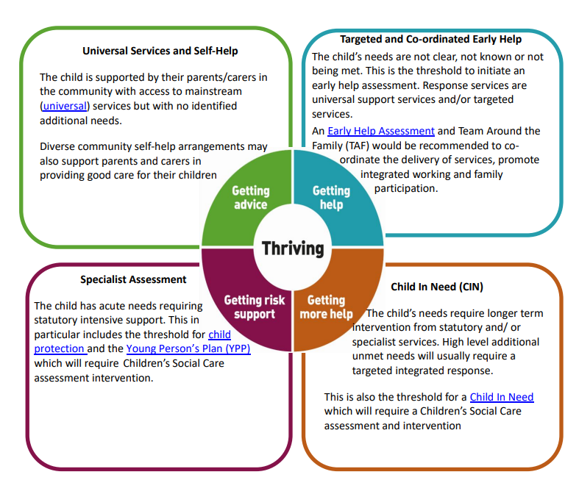

APPENDIX 2

School Child Protection Procedures

1. What Should Staff/Volunteers Do If They Have Concerns About A Child or Young Person in School?

Practitioners in schools who are concerned about a child’s welfare or who believe that a child is or may be at risk of harm from abuse or neglect should pass any information to the Designated Safeguarding Person/Lead in school; this should always occur as soon as possible and certainly within 24 hours:

The Designated Safeguarding Person/Lead) is: Mrs M Done

The Deputy Designated Safeguarding Person/Lead(s) for Child Protection is: Miss Emma Hambleton

It is these senior colleagues who are responsible for taking action where the welfare or safety of children or young people is concerned. If staff are uncertain about whether their concerns are indeed ‘child protection’ then a discussion with their Designated Person/Lead will assist in determining the most appropriate next course of action. The multi agency Bridge Partnership team can also be consulted, where you will be able to speak to a qualified social worker if necessary for support and advice.

Staff should never:
- Do nothing/assume that another agency or practitioner will act or is
acting.
- Attempt to resolve the matter themselves alone.

What should the Designated Safeguarding Person/Lead consider right at the outset?
- Am I dealing with ‘risk’ or ‘need’? (By definition, a child at risk is also a child in need. However, what is the priority / level and immediacy of risk / need?)
- Can the level of need identified be met:
- In or by the school or by accessing universal services
- By undertaking a Early Help Assessment, without referral to the Bridge Partnership
- By working with the child, parents and colleagues?
- What resources are available to the practitioner and the school and what are their limitations?
- Is the level of need such that a referral needs to be made to the Bridge Partnership which requests that an assessment of need be undertaken? (Section 17 Child in Need referral)
- Is the level and/or likelihood of risk such that a child protection referral needs to be made (i.e. a child is suffering or is likely to suffer significant harm? (Section 47 Child Protection referral)
- What information is available re: Child, Parents, Family & Environment?
- What information is inaccessible and, potentially, how significant might this be? For example has the parent/carer denied that there is a problem and failed to co-operate with the school in resolving the issue?
- Who do I/don’t I need to speak to now and what do they need to know?
- Where can I access appropriate advice and/or support?
- If I am not going to refer, then what action am I going to take? (e.g. time-limited monitoring plan, discussion with parents or other practitioners, recording etc)

2. Feedback to staff who report concerns to the Designated Safeguarding Lead

Rules of confidentiality mean that it may not always be possible or appropriate to feedback to staff who report concerns to them. Such information will be shared on a ‘need to know’ basis only and the Designated Person/Lead will decide which information needs to be shared, when and with whom. The primary purpose of confidentiality in this context is to safeguard and promote the child’s welfare.

3. Thresholds for Referral to the Bridge Partnership

In making a decision about whether a referral to the Bridge Partnership may be required, there are two thresholds for (and their criteria) and types of referral that need to be carefully considered:

- Is this a Child In Need?

Under section 17 (s.17(10)) of the Children Act 1989, a child is in need if:
- He is unlikely to achieve or maintain, or to have the opportunity to achieve or maintain, a reasonable standard of health or development, without the provision of services by a local authority;
- His health or development is likely to be impaired, or further impaired, without the provision of such services;
- He is disabled.

- Is this a Child Protection Matter?

Under section 47(1) of the Children Act 1989, a local authority has a duty to make enquiries where they are informed that a child who lives or is found in their area:
- is the subject of an Emergency Protection Order;
- is in Police Protection; or where they have
- reasonable cause to suspect that a child is suffering or is likely to suffer significant harm.

Therefore, it is the ‘significant harm’ threshold’ that justifies statutory intervention into family life. A practitioner making a child protection referral under s.47 must therefore provide information which clearly outlines that a child is suffering or is likely to suffer significant harm. The Designated Safeguarding Person/Lead will make judgements around ‘significant harm’, levels of ‘need’ and when to refer

4. Making Referrals to CSC (Guidance for the Designated Safeguarding Lead)

(i) Child in Need/Section 17 Referrals

- Where an Early Help Assessment already exists, the DSL should send this with the referral to the Bridge Partnership.

- This is a request for assessment/support/services and, as such, you must obtain the consent of the parent(s) (and child/young person where appropriate). This should also be identified on the TAF.

- Where a parent/carer/young person refuses to consent, you should make clear your ongoing plans and responsibilities in respect of support, monitoring etc, and the possibility of a child protection referral at some point in future if things deteriorate or do not improve. (This is not about threats or saying that this is inevitable but about openness and transparency in dealings with parents).

(ii) Child Protection/Section 47 Referral

- Make a telephone call to the Bridge Partnership and forward for consideration.

- If a TAF exists this should be forwarded to the Bridge Partnership as soon as possible and certainly within 48 hours.

- You do not require the consent of a parent or child/young person to make a child protection referral

- A parent should, under most circumstances, be informed by the referrer that a child protection referral is to be made. The criteria for not informing parents are:
- Because this would increase the risk of significant harm to a child(ren); or
- Because, in the referrer’s professional opinion, to do so might impede an investigation that may need to be undertaken;
- Because there would be an undue delay caused by seeking consent which would not serve the child’s best interests.

Fear of jeopardising a working relationship with parents because of a need to refer is not sufficient justification for not making a referral nor for not telling them that you need to refer. Lack of openness will do little to foster ongoing trust, particularly as the source of referrals will be disclosed to parents except in a limited number of circumstances. If you feel that your own or another adult’s immediate safety would be placed at risk by informing parents then you should seek advice and/or make this clear on the CAF and in any telephone contact with the Bridge Partnership.

5. Bridge Partnership Responses to Referrals and Timescales

In response to a referral, the Bridge Partnership may decide to:

- Provide advice to the referrer and/or child/family;
- Refer on to another agency who can provide services;
- Convene a Strategy Meeting ;
- Provide support services under Section 17;
- Undertake an social work assessment(completed within 45 working days);
- Convene an Initial Child Protection Conference (within 15 working days of a Strategy Meeting)
- Accommodate the child under Section 20 (with parental consent);
- Make an application to court for an Order;
- Take no further action.

6. Feedback from the Bridge Partnership

The Bridge Partnership has 24 hours within which to make a decision about a course of action in response to a referral. A Designated Safeguarding Person/Lead should expect to receive written confirmation about action following any referral within 7 days. If you do not receive any (same day) verbal feedback following an urgent child protection referral, and where this places school/a child or children in a vulnerable position, you should ask to speak to a Duty Social Worker, or the relevant Team Manager.

